File name = sciencePsychology.docx
Canfield 10/18/18

`The Science of Psychology
What you need to know about the science of psychology
This document has two purposes: (1) show fundamental characteristics of parametric statistics; and (2) present a philosophy of science - obtaining internal and external validity of research results.

Terms used below: GLM (general linear model); ES (effect size); ANOVA (analysis of variance); MANOVA (multivariate analysis of variance); MR (multiple regression); DFA (discriminant function analysis); CCA (canonical correlation analysis); EFA (exploratory factor analysis).

“…because all classical parametric analyses are part of the GLM, all of these analyses have certain things in common, including the facts that they (a) are ultimately correlational in nature, (b) yield r²-type effect sizes, (c) maximize shared variance between variables or between sets of variables, and ( d) apply weights to observed variables to create synthetic (i.e., unobserved, latent) variables that often become the focus of the analysis (cf. Bagozzi, Fornell, & Larcker, 1981; Cohen, 1968; Henson, 2000; Knapp, 1978; Thompson, 1991).” Sherry

Further,
“Contrary to the compartmentalized understanding of statistical methods held by many researchers, CCA subsumes both univariate and multivariate methods as special cases (Fan, 1996, 1997; Henson, 2000; Thompson 2000). Actually, structural equation modeling represents the highest level of the GLM. However, structural equation modeling explicitly includes measurement error as part of the analysis, whereas other classical statistical procedures do not. Knowledge of the inner workings of CCA can inform researchers regarding the application of GLM concepts across analyses and extension of these concepts to vital multivariate methods (Fish, 1988).” Sherry

Finally, a whole bunch of t-test or correlations result in “Increased risk of this error occurs when too many statistical tests are performed on the same variables in a data set, with each test having its own risk of Type I error (often set by tradition at α = .05 and sometimes called "testwise error"). Multivariate techniques minimize this because they allow for simultaneous comparisons among the variables rather than requiring many statistical tests be conducted.” Sherry

Effect size (ES) contains the basic concept of psychological science. It implies something is causing something and it is known in some quantity between 0 and 1. A 0 [zero] indicates no effect and a 1 indicates “for sure” and full strength.

Here is a list of some of the effect sizes, r, d, g, h, OR, RR, R, r², R², n²
Each of these can be converted to any of the other. Either r or d might be considered the standards. r will be used here with implied directionality implied in regression. That is there is an independent and dependent variable. The statistics t and f can be converted to r.

So r is described and it can be converted to any of the other effect sizes (ES) and vice versa. How does r work in terms of an ES? You might ask the question “Do people who feel like they have been productive feel worthwhile?” At the moment we will not struggle with the opposite that “feeling worthwhile” might cause “productivity” or there might be 100 hundred other things that resulted in the person feeling “worthwhile.” The correlation (and consequently the ES) between “productivity” and “worthwhile” is .53. When people are productive then they feel worthwhile.
We also might believe that there are other things that lead to our feeling worthwhile. It might be that helping another person might make us feel worthwhile. You might help another person by “ … arranging things to help them get something done” (part of a questionnaire) and find that the correlation is .34. And there may be other things like “ doing what you should” . 42 that make people feel worthwhile. But maybe those overlap. A multiple regression would indicate the amount of overlap. In a multiple regression the 3 variables raise the multiple R to .59. Yes, they do overlap. If they did not overlap the total correlation would be .53 + .34 + .42 = 1.29. What happened? In the output of the part correlations (the unique correlation of each variable) are productive = .37 , should = .24 , and arrange = .07. Each one has been reduced considerable because they accounted for some the same variance. The standardized beta weights are productive= .42 , should = .26 , and arrange = .08. And consequently, the standardized linear combination
(Y’=b₁x₁ + b₂x₂ + b₃x_{3…} b_{n}x_{n}) is
Y’=.41 times productiv + .08 times arrange + .26 times should.
Annotated SPSS output from the multiple regression analysis``` follow:
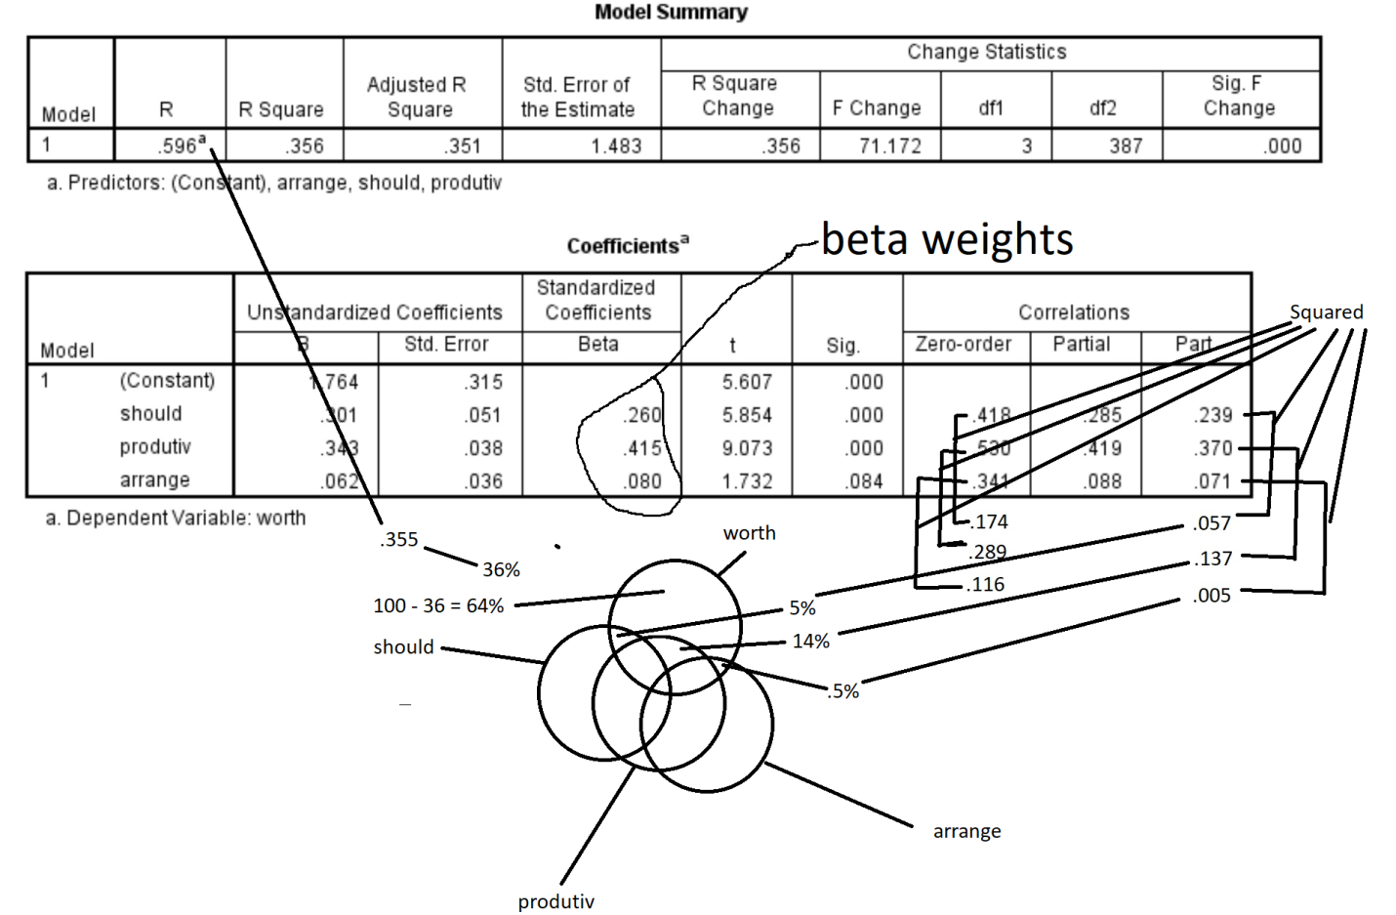

Now to do the same calculation in CCA
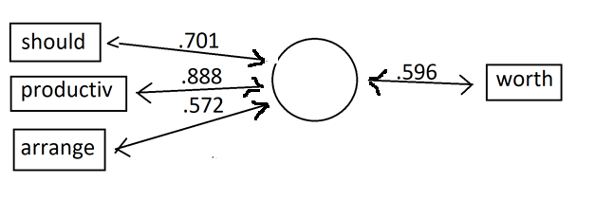
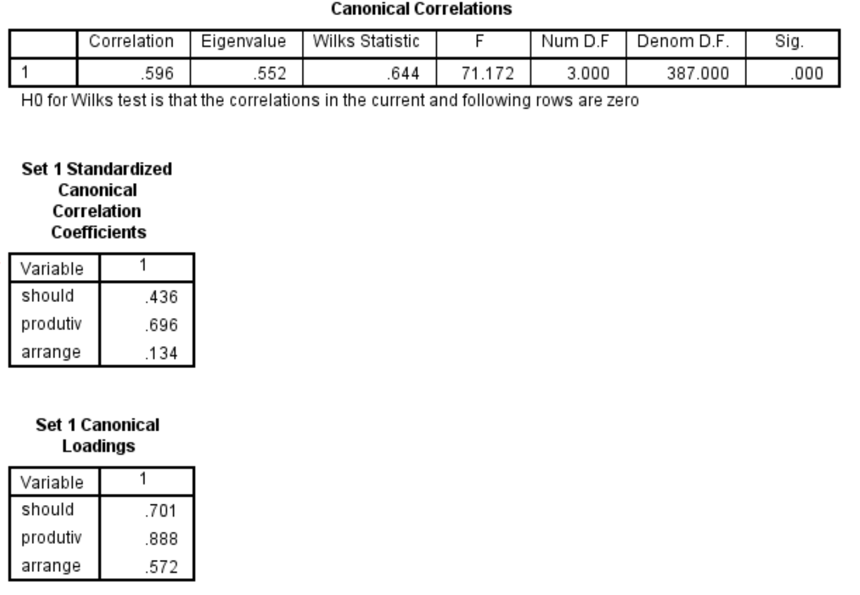k

Now we add multiple independent variables using canonical correlations
It may be that feeling worthwhile is part of a broader concept that might include feeling good about oneself and enjoying oneself.
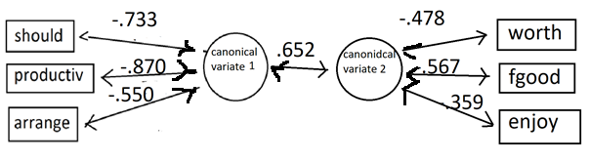
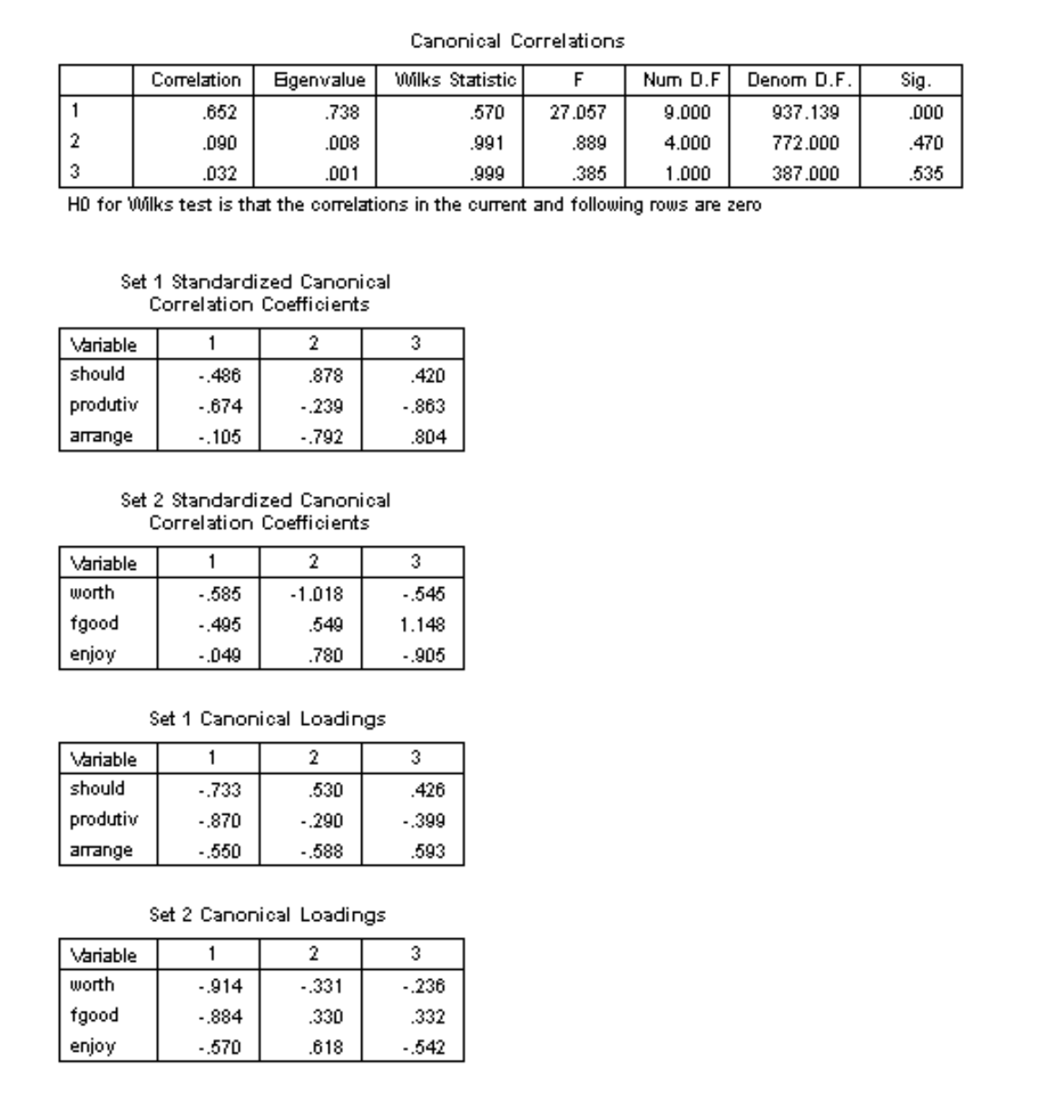

But only 2 of the additional three are significant. “Arrange” does not raise the overall correlation significantly.

We will leave that for the moment and think about the concept of “worthwhile” – it might be that the emotions of feeling good about one’s self and enjoying oneself might overlap with feeling worthwhile. So let’s see if being productive, doing what you should, and arranging to help another person with predict (effect – from effect size) one’s feeling of worthwhileness, enjoyment, and feeling good about one’s self. We will do that by running a canonical correlation coefficient.

Next we can use the canonical program to generate a discriminant. The following is fake data with “dummy diagnosis” variable.

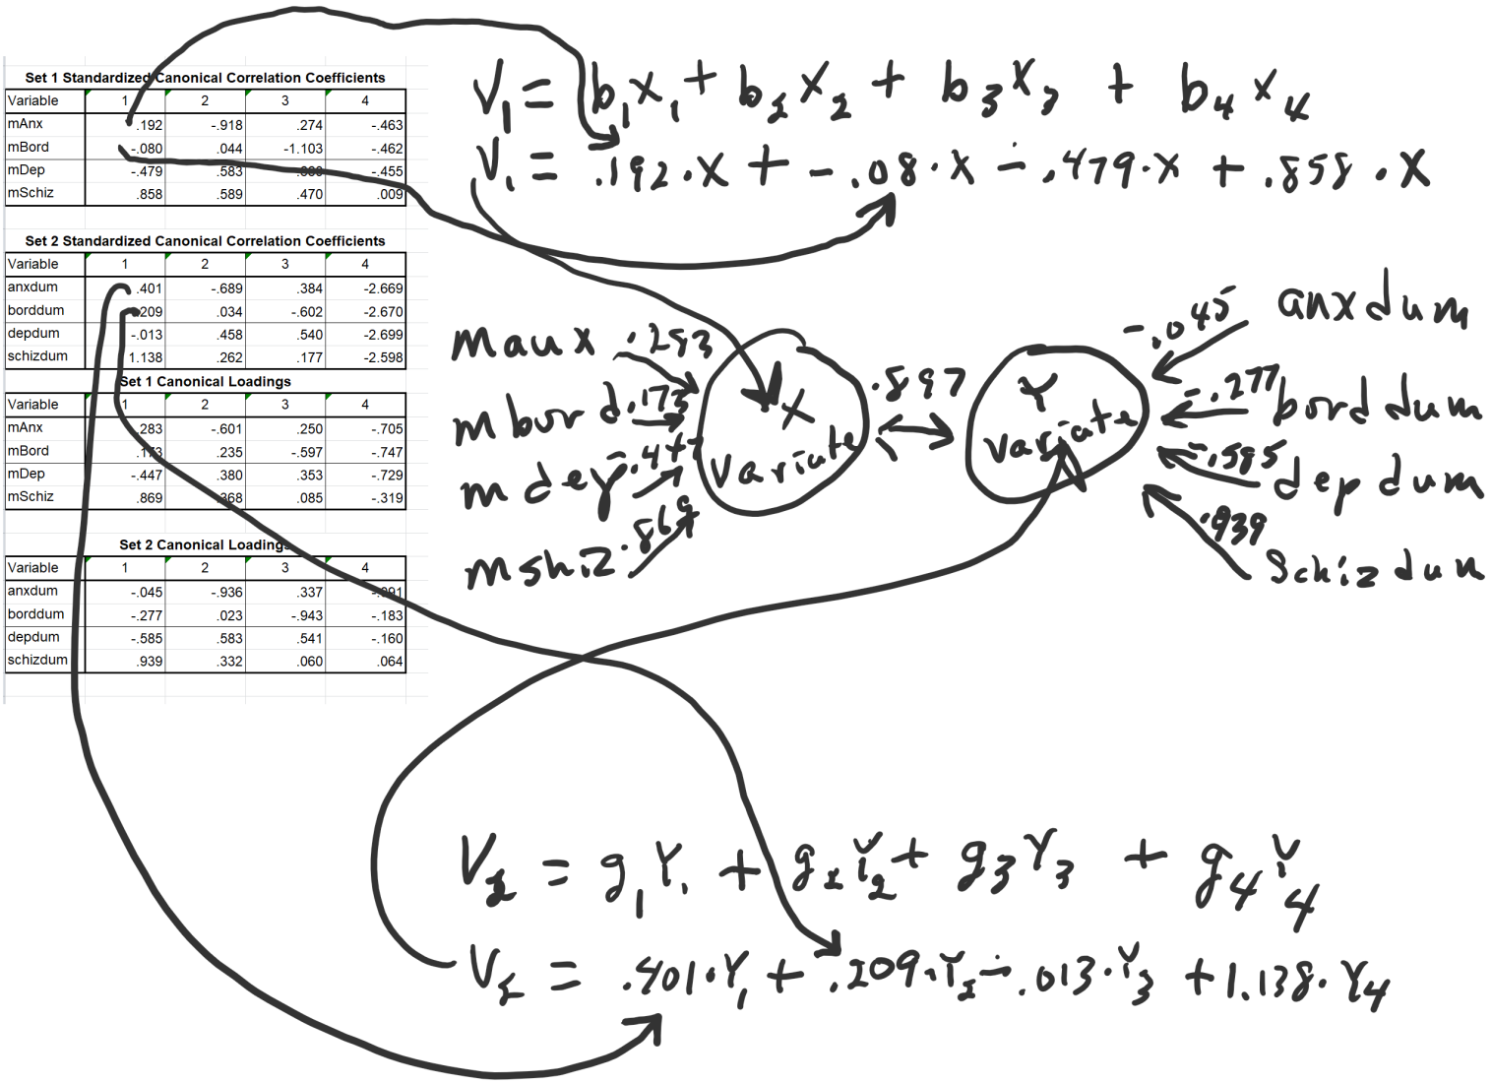
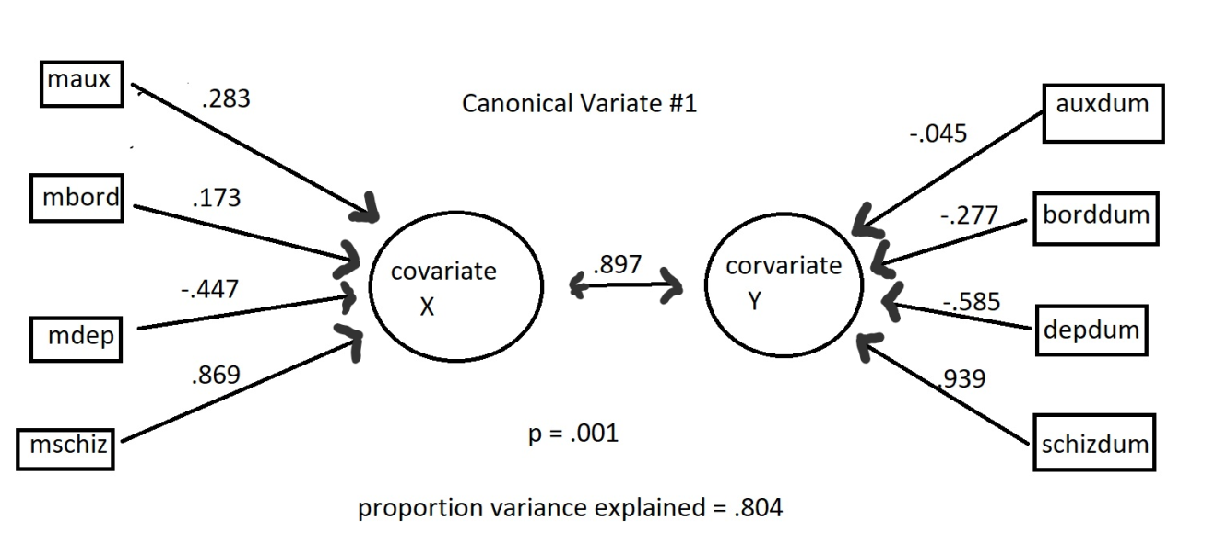

Or we can make the independent variable categorical (through the transformation to dummy variable) and it becomes comparable to MANOVA
It results in a canonical correlation of .883

In an eqs model the regression coefficient is .88.

