Multiple Regression prediction diagnostic categories using dummy variables.
Diagdum1.sps
compute anxdum=0.
compute borddum=0.
compute depdum=0.
compute schizdum=0.
if (diagn=1) anxdum=1.
if (diagn=2) borddum=1.
if (diagn=3) depdum=1.
if (diagn=4) schizdum=1.
execute.

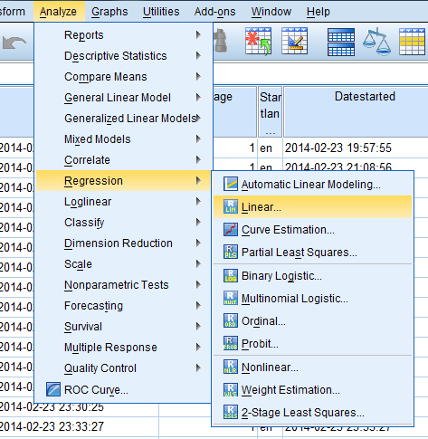

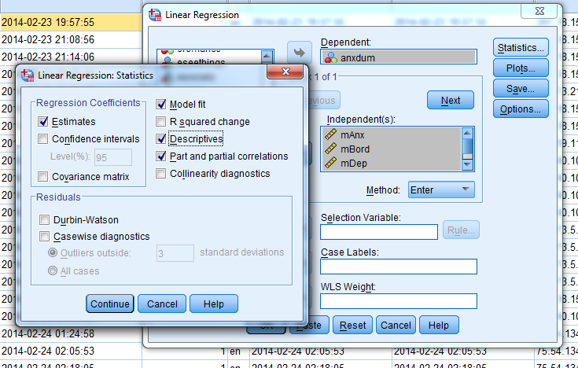

regDiagdum1.sps
REGRESSION
/DESCRIPTIVES MEAN STDDEV CORR SIG N
/MISSING LISTWISE
/STATISTICS COEFF OUTS R ANOVA ZPP
/CRITERIA=PIN(.05) POUT(.10)
/NOORIGIN
/DEPENDENT anxdum
/METHOD=ENTER mAnx mBord mDep moAnx.

REGRESSION
/DESCRIPTIVES MEAN STDDEV CORR SIG N
/MISSING LISTWISE
/STATISTICS COEFF OUTS R ANOVA ZPP
/CRITERIA=PIN(.05) POUT(.10)
/NOORIGIN
/DEPENDENT borddum
/METHOD=ENTER mAnx mBord mDep moAnx.

REGRESSION
/DESCRIPTIVES MEAN STDDEV CORR SIG N
/MISSING LISTWISE
/STATISTICS COEFF OUTS R ANOVA ZPP
/CRITERIA=PIN(.05) POUT(.10)
/NOORIGIN
/DEPENDENT depdum
/METHOD=ENTER mAnx mBord mDep moAnx.

REGRESSION
/DESCRIPTIVES MEAN STDDEV CORR SIG N
/MISSING LISTWISE
/STATISTICS COEFF OUTS R ANOVA ZPP
/CRITERIA=PIN(.05) POUT(.10)
/NOORIGIN
/DEPENDENT schisdum
/METHOD=ENTER mAnx mBord mDep moAnx.

