Flowers cause joggers
A Martian Story
Fable by Merle Canfield
A Martian comes to earth to do a study of People. She notices that these People gather in “clumps” (that is Martian for towns and cities). She notices that People sometimes run up and down the streets in these clumps – she calls the running People Joggers (what a coincidence). She wonders why they do that since they don’t seem to be going anywhere in particular like the other People seem to be. She notices that there are often flowers where these joggers and decides maybe that is it. She sets up a data table like this.

number flowers | number joggers | Temperature | Month
0 | 0 | 1 | jan
0 | 1 | 4 | jan
0 | 0 | 6 | jan
30 | 2 | 19 | jan
50 | 7 | 21 | feb
50 | 12 | 20 | feb
50 | 15 | 26 | feb
50 | 12 | 24 | feb
300 | 19 | 42 | mar
305 | 20 | 45 | mar
308 | 23 | 47 | mar
309 | 20 | 45 | mar
4000 | 49 | 65 | apr
4021 | 50 | 66 | apr
4000 | 53 | 67 | apr
4078 | 50 | 68 | apr
4030 | 101 | 72 | may
4000 | 108 | 73 | may
4016 | 156 | 70 | may
4000 | 104 | 72 | may
4500 | 199 | 93 | jun
4545 | 200 | 94 | jun
4500 | 223 | 92 | jun
4599 | 200 | 96 | jun
4004 | 245 | 94 | jul
4000 | 207 | 90 | jul
4043 | 200 | 90 | jul
4000 | 203 | 93 | jul
3500 | 150 | 86 | aug
3500 | 150 | 86 | aug
3500 | 150 | 86 | aug
3567 | 150 | 86 | aug
2030 | 100 | 84 | sep
2032 | 106 | 83 | sep
2023 | 100 | 82 | sep
2000 | 102 | 83 | sep
1500 | 100 | 76 | oct
1500 | 99 | 76 | oct
1500 | 100 | 76 | oct
1543 | 89 | 76 | oct
402 | 50 | 53 | nov
460 | 55 | 51 | nov
400 | 50 | 49 | nov
400 | 54 | 46 | nov
300 | 31 | 53 | dec
300 | 25 | 40 | dec
304 | 23 | 28 | dec
300 | 25 | 34 | dec

[We will pretend that she did not gather the temperature data here. Save space.]

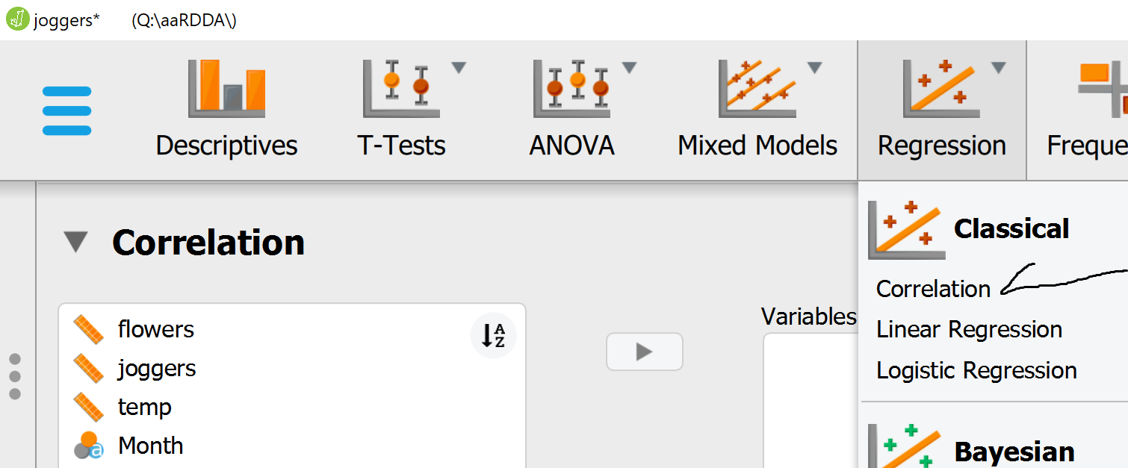

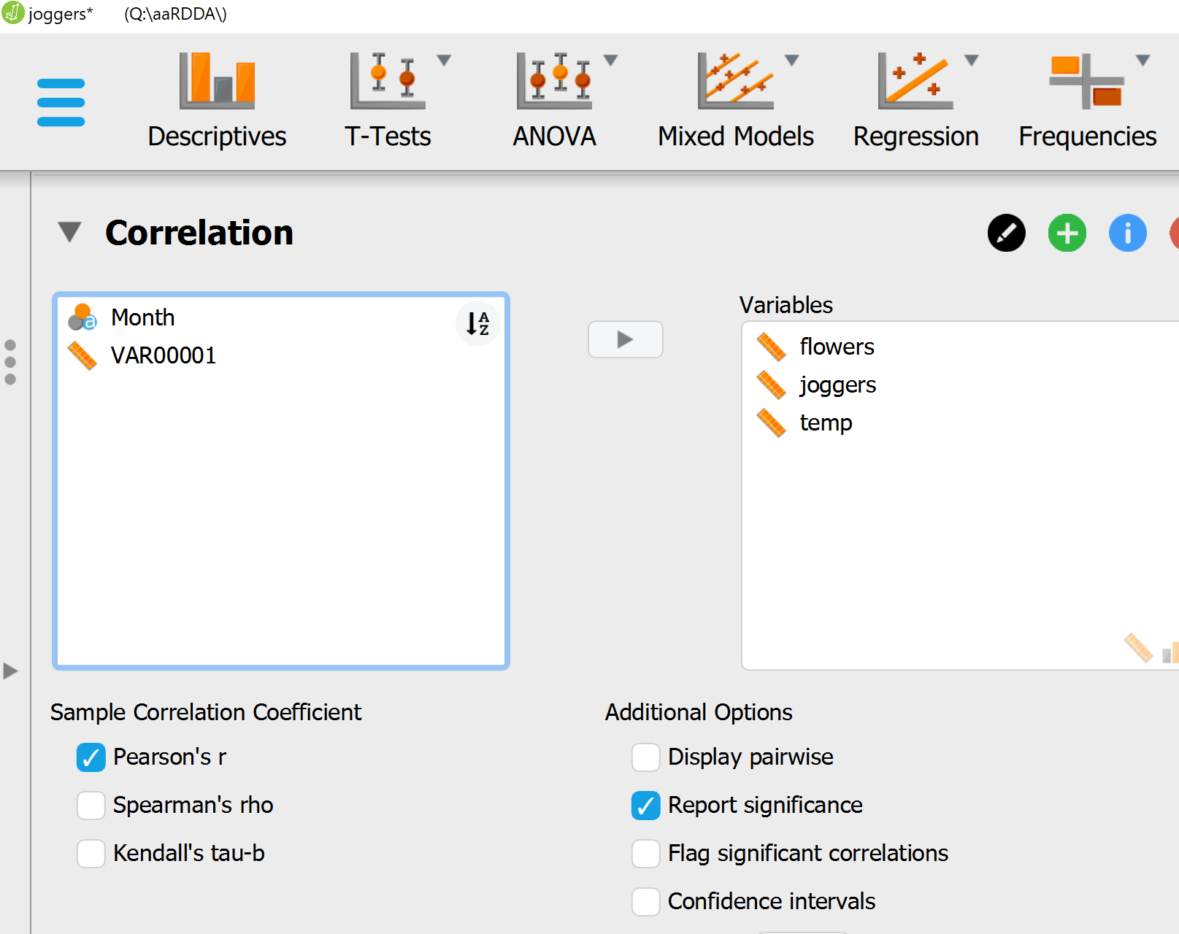

Correlation
Pearson's Correlations
Variable |  |  |  | flowers |  | joggers |  | temp
1. flowers |  | Pearson's r |  | —
 |  | p-value |  | —
2. joggers |  | Pearson's r |  | 0.818 |  | —
 |  | p-value |  | < .001 |  | —
3. temp |  | Pearson's r |  | 0.824 |  | 0.880 |  | —
 |  | p-value |  | < .001 |  | < .001 |  | —

[Nor have the temperature correlations here.]

- She finds a correlation of .81 accounting for .66% of the variance. Takes these data and presents at the “Mars Research on the Activities of the Earth People.” At the conference guy announces: “You dummy it is probably the outside temperature that is causing both. You should be banned from MRAEP.” [Those male Martians have a way with words.] She goes back to Earth and collects additional data.

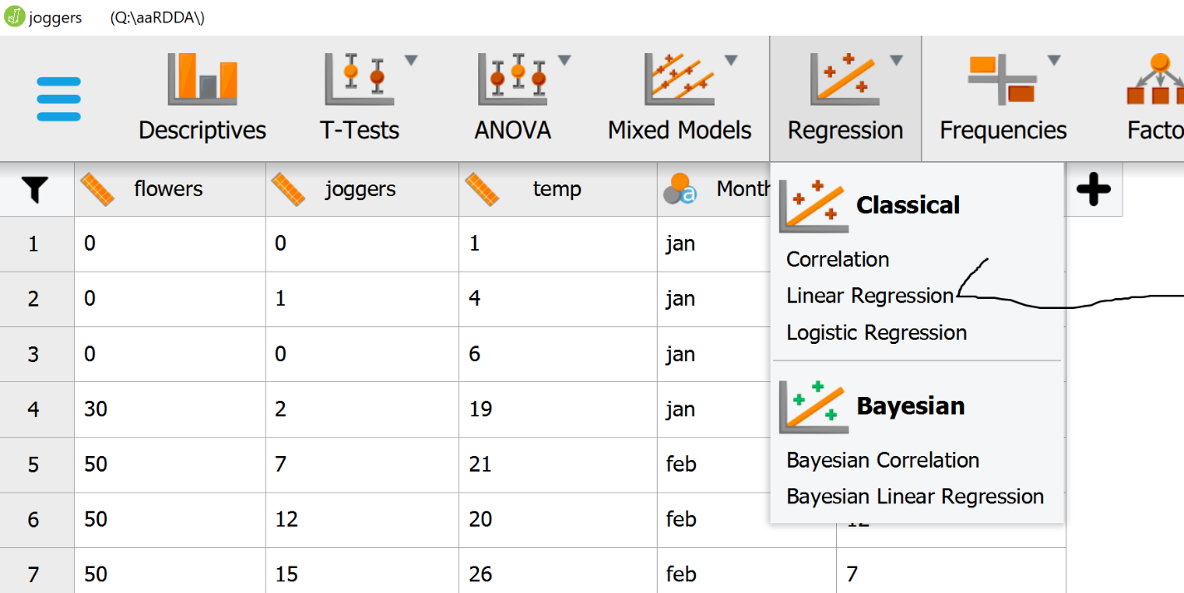

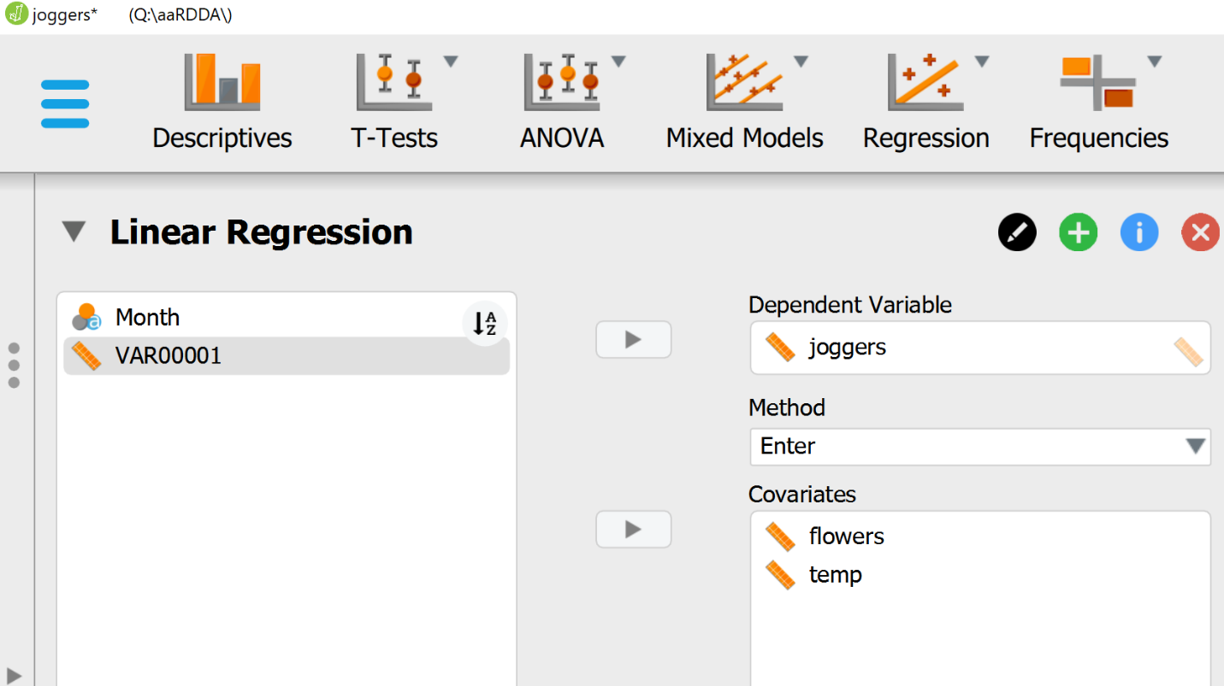

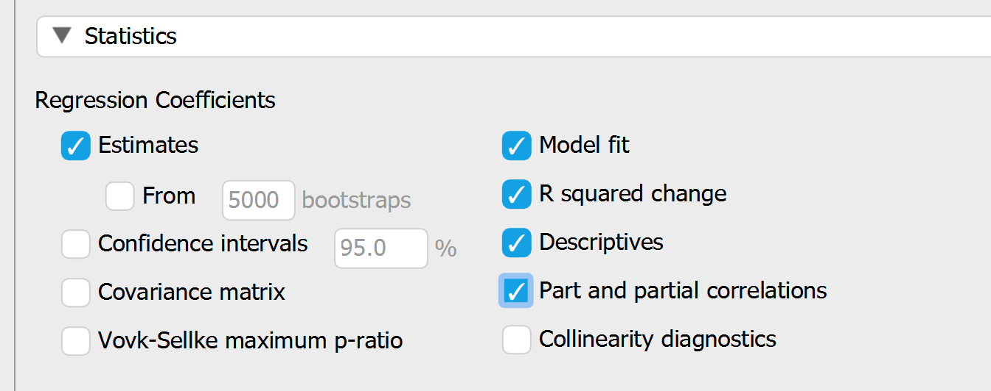

Linear Regression
Model Summary – joggers
Model |  | R |  | R² |  | Adjusted R² |  | RMSE |  | R² Change |  | F Change |  | df1 |  | df2 |  | p
H₀ |  | 0.000 |  | 0.000 |  | 0.000 |  | 71.539 |  | 0.000 |  |  |  | 0 |  | 47
H₁ |  | 0.895 |  | 0.801 |  | 0.792 |  | 32.595 |  | 0.801 |  | 90.704 |  | 2 |  | 45 |  | < .001

ANOVA
Model |  |  |  | Sum of Squares |  | df |  | Mean Square |  | F |  | p
H₁ |  | Regression |  | 192728.616 |  | 2 |  | 96364.308 |  | 90.704 |  | < .001
 |  | Residual |  | 47808.384 |  | 45 |  | 1062.409
 |  | Total |  | 240537.000 |  | 47
Note. The intercept model is omitted, as no meaningful information can be shown.

Coefficients
Model |  |  |  | Unstandardized |  | Standard Error |  | Standardized |  | t |  | p
H₀ |  | (Intercept) |  | 87.250 |  | 10.326 |  |  |  | 8.450 |  | < .001
H₁ |  | (Intercept) |  | -38.623 |  | 12.872 |  |  |  | -3.001 |  | 0.004
 |  | flowers |  | 0.012 |  | 0.005 |  | 0.290 |  | 2.470 |  | 0.017
 |  | temp |  | 1.669 |  | 0.306 |  | 0.641 |  | 5.459 |  | < .001

Descriptives
 |  | N |  | Mean |  | SD |  | SE
joggers |  | 48 |  | 87.250 |  | 71.539 |  | 10.326
flowers |  | 48 |  | 2059.354 |  | 1778.566 |  | 256.714
temp |  | 48 |  | 61.021 |  | 27.469 |  | 3.965

Part And Partial Correlations
Model |  |  |  | Partial |  | Part
H₁ |  | flowers |  | 0.345 |  | 0.164
 |  | temp |  | 0.631 |  | 0.363
Note. The intercept model is omitted, as no meaningful information can be shown.

- The critic was right. The outdoor temperature assessed by the part correlation (unique variance) of the outdoor temperature is .88 accounting for 77% of the variance. However, the part correlations indicate that when they are entered together the temperature part correlation is .36 (accounting for 13% of the variance and the part correlation for flowers is still significant at .16 and accounting for 3% of the variacne. So the flowers still have potential effect. However, she thinks that there might be other influences.

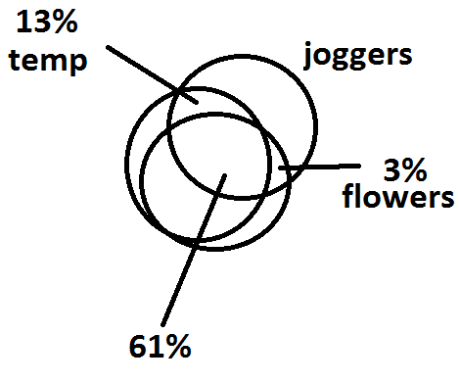
- But Wait! Maybe joggers cause flowers.
- We changed the flowers to the dependent variable

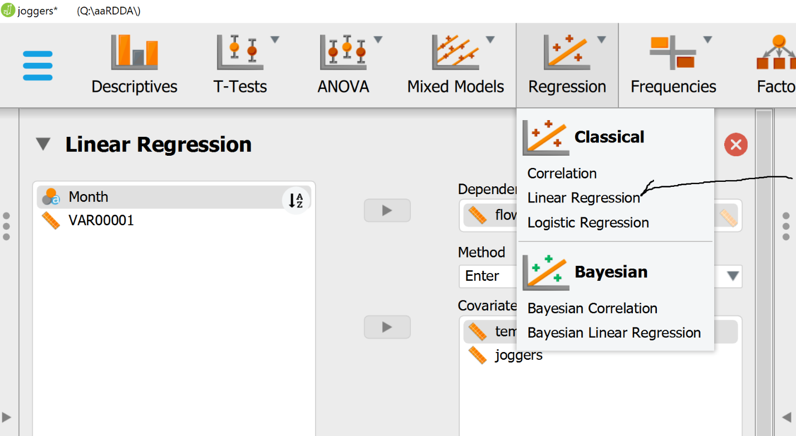
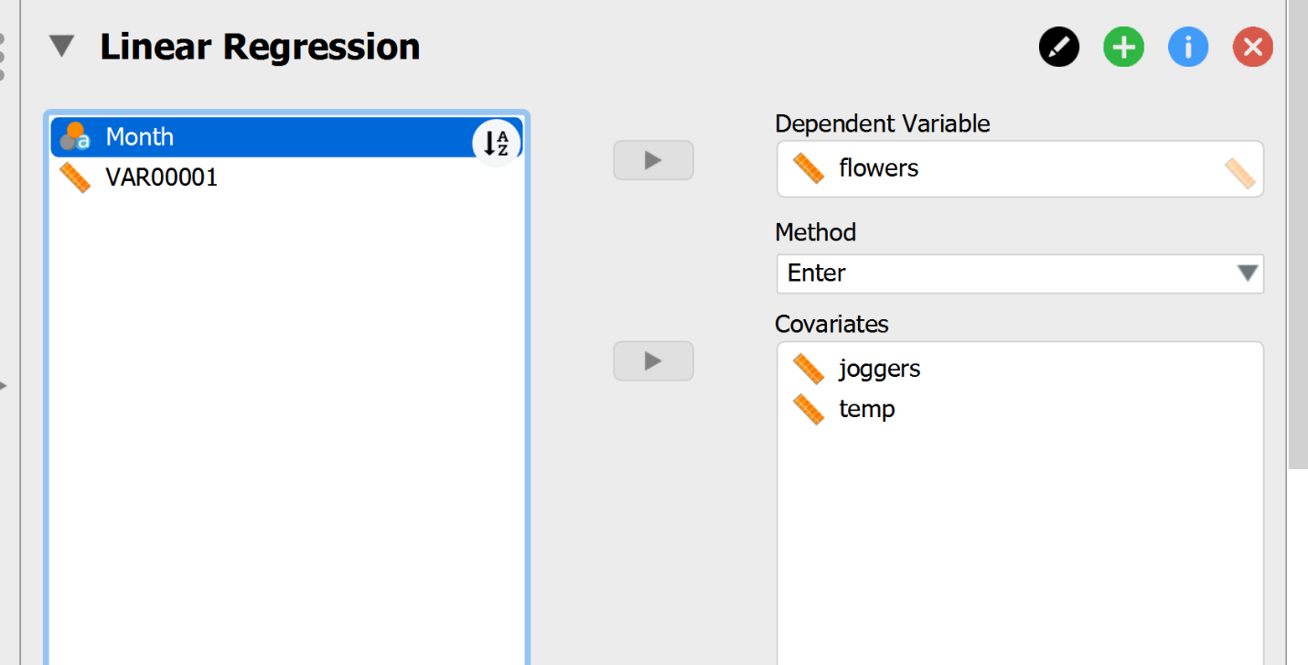

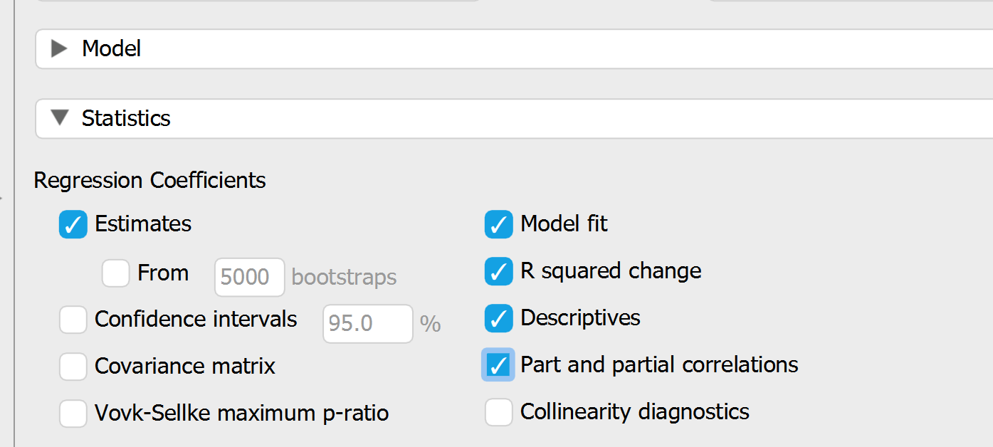

Correlation
Pearson's Correlations
Variable |  |  |  | flowers |  | joggers |  | temp
1. flowers |  | Pearson's r |  | —
 |  | p-value |  | —
2. joggers |  | Pearson's r |  | 0.818 |  | —
 |  | p-value |  | < .001 |  | —
3. temp |  | Pearson's r |  | 0.824 |  | 0.880 |  | —
 |  | p-value |  | < .001 |  | < .001 |  | —

Linear Regression
Model Summary - flowers
Model |  | R |  | R² |  | Adjusted R² |  | RMSE |  | R² Change |  | F Change |  | df1 |  | df2 |  | p
H₀ |  | 0.000 |  | 0.000 |  | 0.000 |  | 1778.566 |  | 0.000 |  |  |  | 0 |  | 47
H₁ |  | 0.847 |  | 0.718 |  | 0.705 |  | 965.541 |  | 0.718 |  | 57.238 |  | 2 |  | 45 |  | < .001

ANOVA
Model |  |  |  | Sum of Squares |  | df |  | Mean Square |  | F |  | p
H₁ |  | Regression |  | 1.067e +8 |  | 2 |  | 5.336e +7 |  | 57.238 |  | < .001
 |  | Residual |  | 4.195e +7 |  | 45 |  | 932269.754
 |  | Total |  | 1.487e +8 |  | 47
Note. The intercept model is omitted, as no meaningful information can be shown.

Coefficients
Model |  |  |  | Unstandardized |  | Standard Error |  | Standardized |  | t |  | p
H₀ |  | (Intercept) |  | 2059.354 |  | 256.714 |  |  |  | 8.022 |  | < .001
H₁ |  | (Intercept) |  | -659.500 |  | 405.964 |  |  |  | -1.625 |  | 0.111
 |  | joggers |  | 10.234 |  | 4.144 |  | 0.412 |  | 2.470 |  | 0.017
 |  | temp |  | 29.923 |  | 10.792 |  | 0.462 |  | 2.773 |  | 0.008

Descriptives
 |  | N |  | Mean |  | SD |  | SE
flowers |  | 48 |  | 2059.354 |  | 1778.566 |  | 256.714
joggers |  | 48 |  | 87.250 |  | 71.539 |  | 10.326
temp |  | 48 |  | 61.021 |  | 27.469 |  | 3.965

Part And Partial Correlations
Model |  |  |  | Partial |  | Part
H₁ |  | joggers |  | 0.345 |  | 0.196
 |  | temp |  | 0.382 |  | 0.220
Note. The intercept model is omitted, as no meaningful information can be shown.

- Only the part correlations are of interest here. Total variance accounted for by both variables is72% (multiple correlation is .85. In this instance we see that both temperature and joggers cause more flowers. However, to get at the real cause we probably need more data in both cases. It is probably sunlight that causes both the temperature and the flowers. However, the flowers were probably planted by some other person (not joggers – but maybe). Further, the planter probably planted the flowers for himself/herself to enjoy but also for other people to enjoy and here we have joggers. Temp part correlation is .22 (5%) and joggers is .20 (4%).

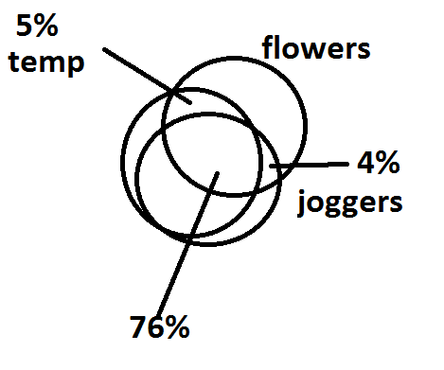
Hummm……
HOWEVER:

When the people who planted the flowers were asked why they planted them the responses were varied. Some said that they enjoyed the process of gardening. Some said so that people going by can enjoy them. So in this latter sense the joggers did cause the flowers to be planted through a mediating variable of the planter.
When the joggers were asked why they were jogging their answers were variad. Some said for health reasons. And addtionally to shape their body and look good. When asked “why here?” they said it was pleasant with the trees and flowers.
So her research was not done there were many other “3rd” variables that could be causal. Or part of the combination of causal variables.

