Creating a Syntax File by typing commands (Job Stream)
Click on "File" and the following screen will appear:
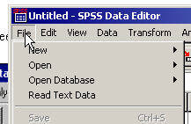
Click on "New" and the following screen will appear:
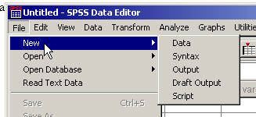
Click on "Syntax" and the following window appears:
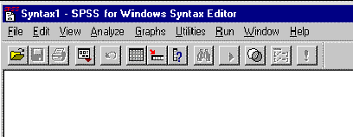
Fill in the Window so that it looks like this (with a different file name):
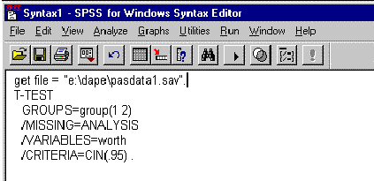

Click here to go to Saving a Syntax File

Copyright Information

