Running Factor Analysis

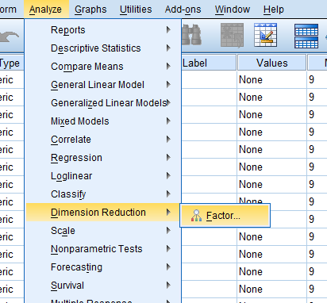
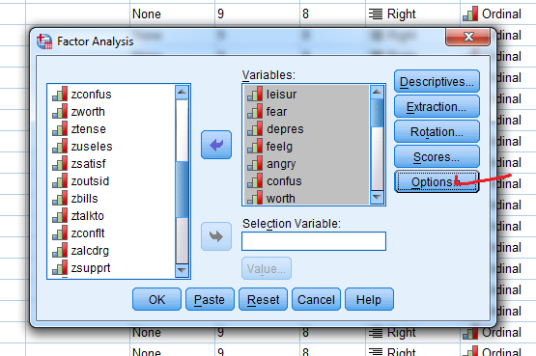
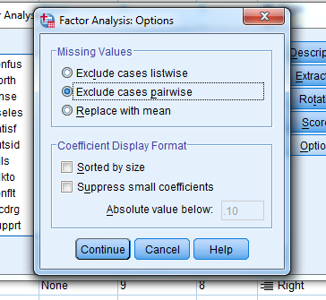
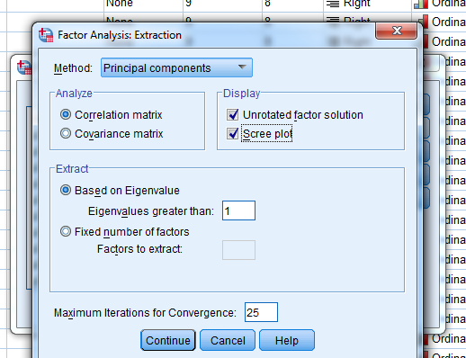

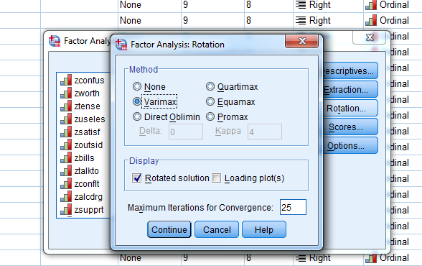
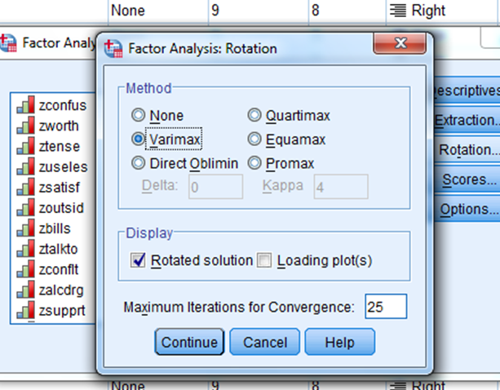
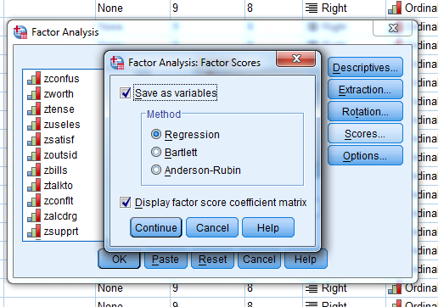
FACTOR
/VARIABLES leisur fear depres feelg angry confus worth tense useles satisf outsid bills talkto
conflt alcdrg supprt employ goodj likew inway money health
/MISSING PAIRWISE
/ANALYSIS leisur fear depres feelg angry confus worth tense useles satisf outsid bills talkto
conflt alcdrg supprt employ goodj likew inway money health
/PRINT INITIAL EXTRACTION ROTATION FSCORE
/PLOT EIGEN
/CRITERIA MINEIGEN(1) ITERATE(25)
/EXTRACTION PC
/CRITERIA ITERATE(25)
/ROTATION VARIMAX
/SAVE REG(ALL)
/METHOD=CORRELATION.

