QuickGuidemediate.docx
Merle Canfield
This guide is for analyzing mediating or intervening variables and factors. Go to Confirmatory Factor analysis notes (QuickGuideConfirmatory) to get to this point. We are going to treat Factor 3 as the mediating (or treatment, or intervention) variable.

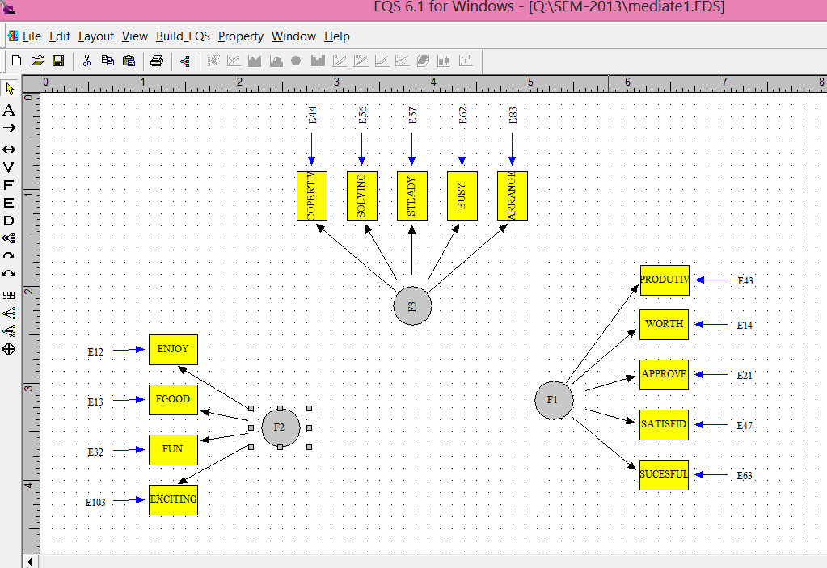
Double click F2 to get the following.
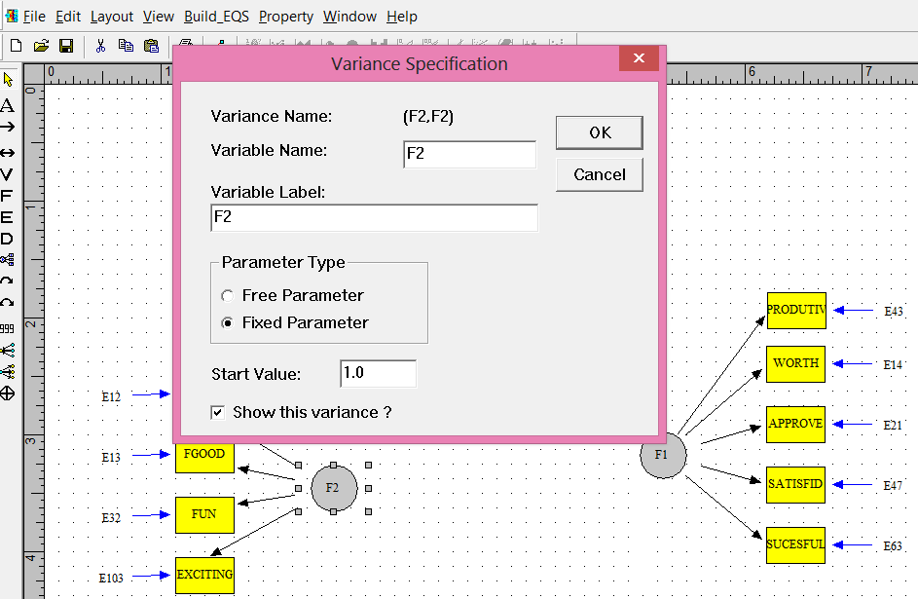

Double click one of the parameters to get the following.
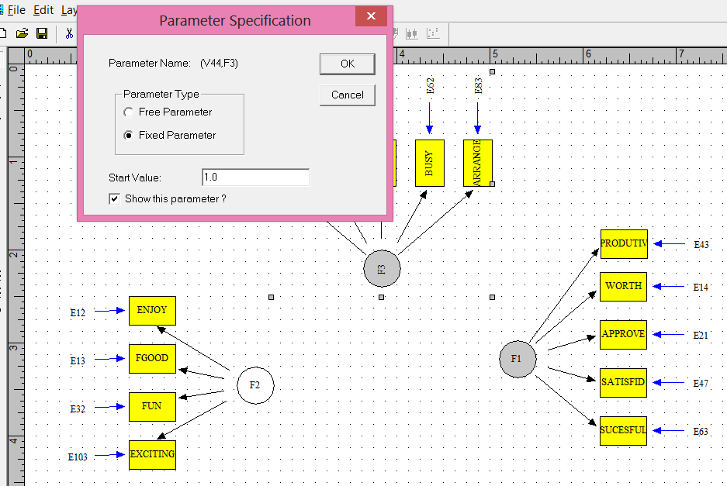

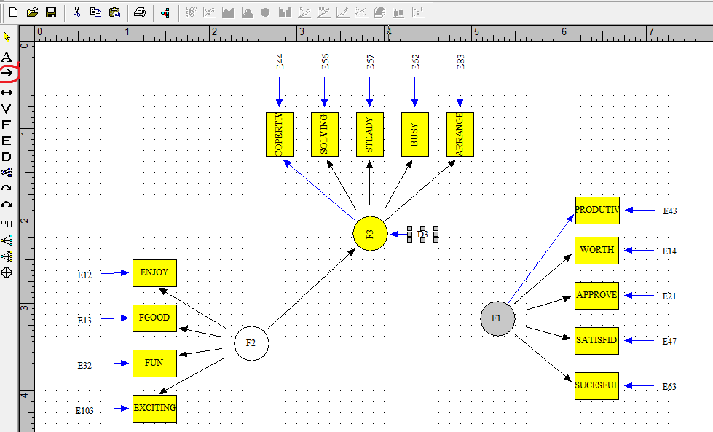

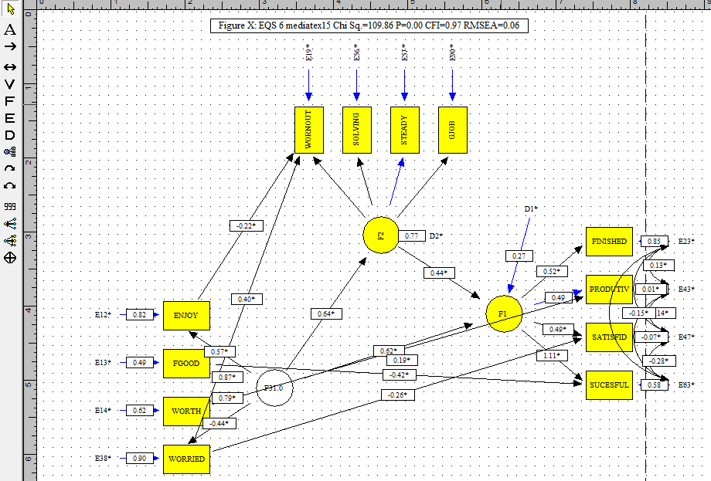

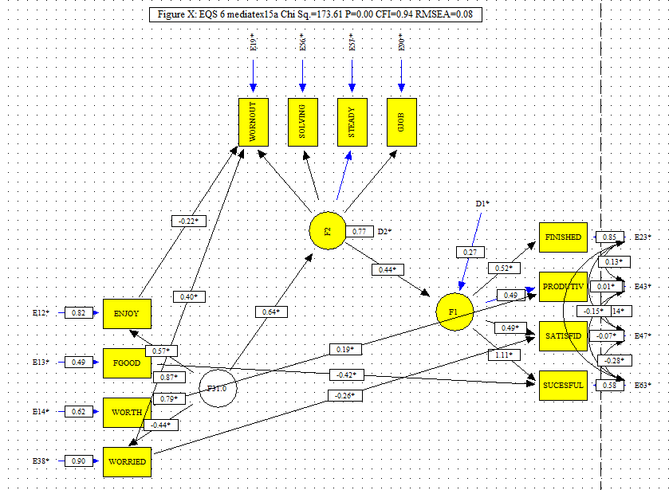
The full model is 109.86 and the F3 to F1 constrained is 173.61 difference is 63.75 and significant at <.05 (3.84). This makes the above an improvement beyond zero and therefore the full mediation is not supported.

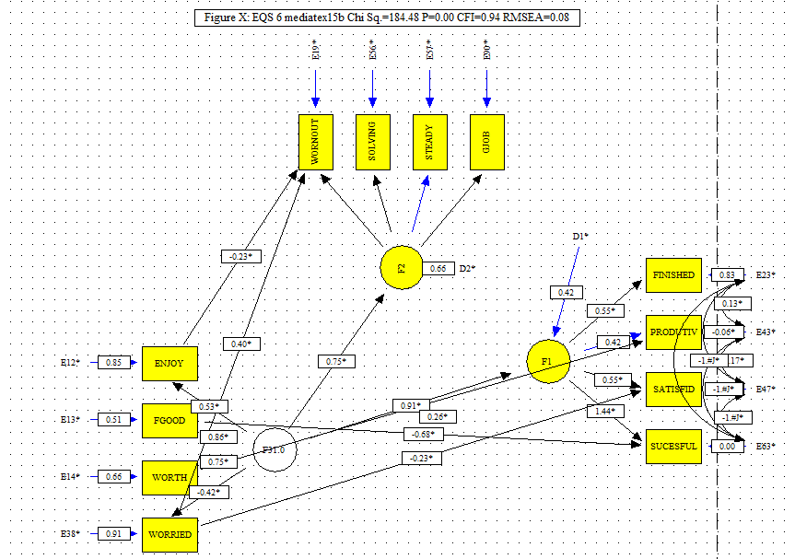
This model shows that the deletion of the parameter from F2 to F1 reduces the influence of F3 to F1 even if it does not reduce it to zero. Consequently, F2 is a partial mediating factor. However, see the discussion below where Little cautions against using the terms partial and full mediation.
The following data is from:
J Child Fam Stud (2006) 15:721–731
DOI 10.1007/s10826-006-9045-x
ORIGINAL PAPER
Family Functioning, Self-Concept, and Severity of
Adolescent Externalizing Problems
Craig E. Henderson · Gayle A. Dakof ·
Seth J. Schwartz · Howard A. Liddle
Published online: 6 June 2006
C _
Springer Science+Business Me
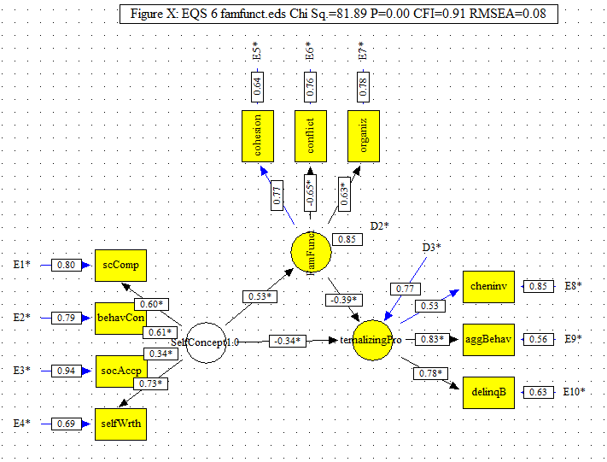

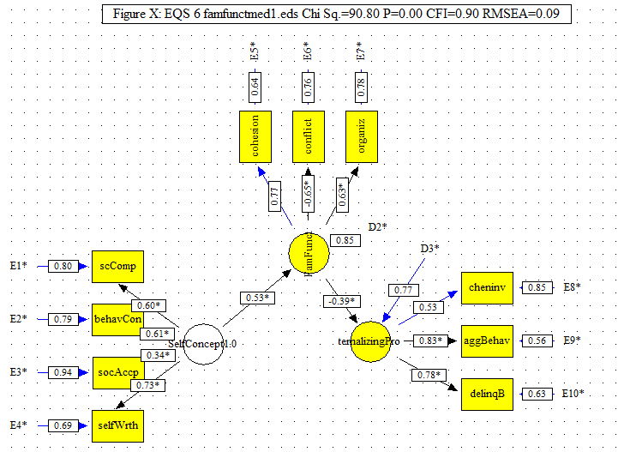
The test of mediation is the comparison of this model to the above model. According to Holmbeck if the model improves then mediation is not supported. If, however, this model is significantly lower than the above model partial medication is supported. Both assume that the relationships among the factors are significant. The chi square difference between the two models is 8.81 and with 1 degree of freedom the difference is statistically significant. According to Holmbeck partial mediation is supported. Little below argues against the use of partial mediation. The authors use Holbeck’s criteria.
“The only remaining step needed to ensure mediation is to constrain the direct path from
self-concept to externalizing problems to zero and reevaluate themodel. When the direct path
from self-concept to externalizing problems was constrained to zero, the model fit worsened,
χ2(32, N = 224) = 160.74, p < .001; CFI = .97; RMSEA = .13. A chi-square difference
test revealed that the fit for this model was significantly worse than was the fit for the model
with the direct-effects path unconstrained, _χ2(1) = 82.87, p < .001.
The reverse mediation model, with self-concept as the mediating variable, demonstrated
worse model fit (BIC = 4963.54) than the direct effects model of family functioning on
externalizing behavior (BIC = 2598.87). Therefore, this mediation model was rejected in
favor of the more parsimonious direct effects model.”
YET.
“Three primary findings emerged from this
investigation: (1) a strong direct relationship between family functioning and externalizing
problems, (2) a strong direct relationship between self-concept and externalizing problems,
and (3) family functioning partially mediated the relationship between self-concept and
externalizing problems. A model examining the extent to which the interaction between
family functioning and self-concept predicted externalizing problems (i.e., a moderation
model) was not supported by the results.”

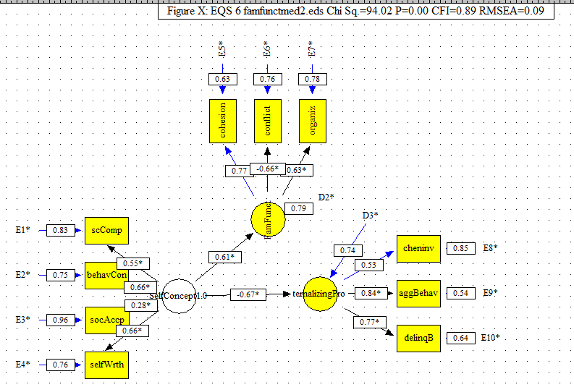

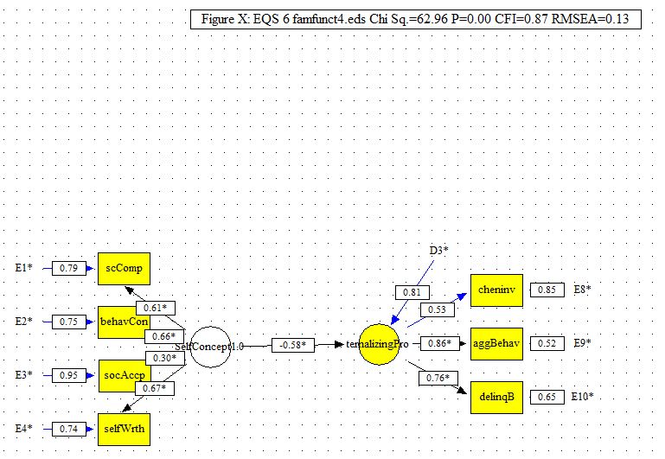

Journal of Consulting and Clinical Psychology
1997, W 65. No. 4, 599-610
Copyright 1997 by the American Psychological Association, Inc.
0022-006XOT/S3.00
Toward Terminological, Conceptual, and Statistical Clarity in the Study
of Mediators and Moderators: Examples From the Child-Clinical
and Pediatric Psychology Literatures
Grayson N. Holmbeck
Loyola University of Chicago
“Assuming that there is a latent predictor variable (A), an hypothesized latent mediator variable (B), and a latent outcome variable (C), one would first assess the fit of the direct effect (A -»C) model (Hoyle & Smith, 1994). Assuming an adequate fit, the investigator than tests the fit of the overall A -» B -» C model. Assuming that the overall model provides an adequate fit, the A -> B and B -> C path coefficients are examined. At this point, the A -> C, A -+ B, and B -> C paths (as well as the A -> B -» C model) should all be significant in the directions predicted (which is analogous to the regression strategy discussed above).”
“The final step in assessing whether there is a mediational effect is to assess the fit of the A -> B -» C model under two conditions: (a) when the A -»C path is constrained to zero, and (b) when the A -»C path is not constrained. One then examines whether the second model provides a significant improvement in fit over the first model. As noted earlier, improvement in fit is assessed with a significance test on the basis of the difference between the two model chi-squares. If there is a mediational effect, the addition of the A -» C path to the constrained model should not improve the fit. In other words, the previously significant A -> C path is reduced to nonsignificance (i.e., it does not improve the fit of the model) when the mediator is taken into account (which is, again, analogous to the regression approach). It is also useful at this point to report and compare the A -> C path coefficients for when B is, versus when B is not, included in the model.”

CHAPTER NINE
Structural Equation Modeling of Mediation
and Moderation With Contextual Factors
Todd D. Little
University of Kansas
Baron and Kenny’s (1986) influential paper on mediation analyses stated three
necessary but not sufficient conditions that must be met in order to claim that
mediation is occurring (but see Kenny, Kashy, & Bolger, 1998; MacKinnon,
Lockwood, Hoffman, West, & Sheets, 2002).
1. X is significantly related to M.
2. M is significantly related to Y.
3. The relationship of X to Y diminishes when M is in the model.
In other words, each of the three constructs must show evidence of a nonzero
monotonic association with each other, and the relationship of X to Y must
decrease substantially upon adding M as a predictor of Y (for a review and
comparison of methods of testing mediation, see MacKinnon et al., 2002).
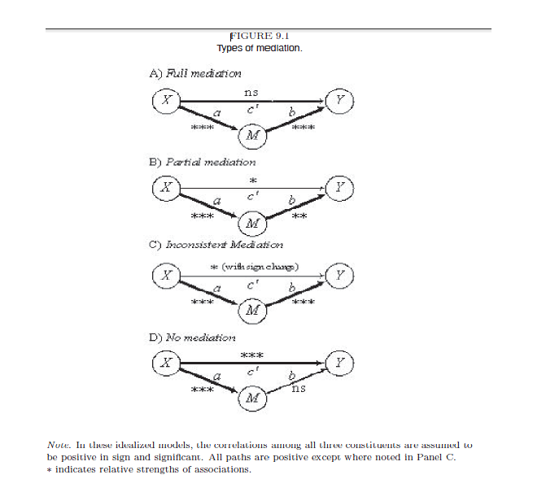

Some Notes of Caution. Despite the pervasiveness of terms like full and
partial mediation, we caution against their use. Full and partial are essentially
informal effect size descriptors.

