MANOVA on ques14

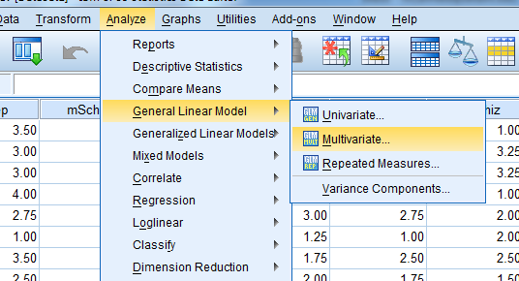

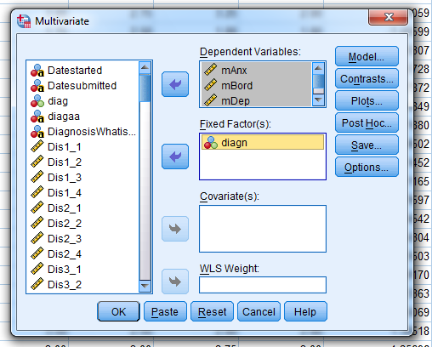

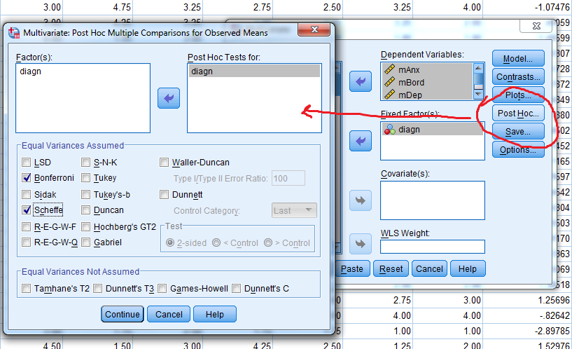

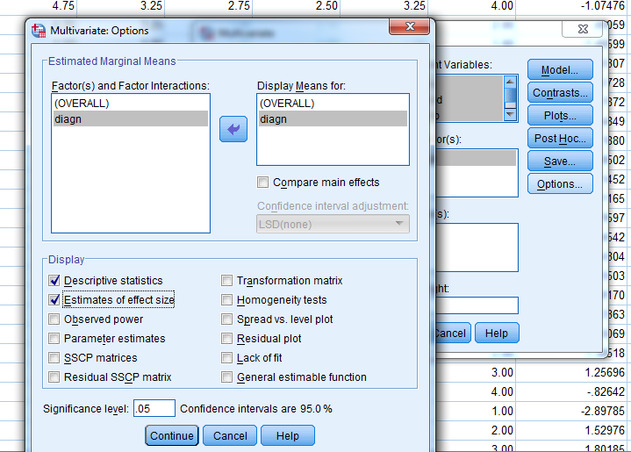
Click on Paste

Manova1.sps
GLM mAnx mBord mDep moAnx BY diagn
/METHOD=SSTYPE(3)
/INTERCEPT=INCLUDE
/POSTHOC=diagn(SCHEFFE BONFERRONI)
/EMMEANS=TABLES(OVERALL)
/EMMEANS=TABLES(diagn)
/PRINT=DESCRIPTIVE ETASQ
/CRITERIA=ALPHA(.05)
/DESIGN= diagn.

