Developing Cut Off Scores from Data
In the fake data file there are variables that identify the diagnostic category of the person and variables that have the scores on the various items and subtests. In this analysis the diagnostic category is needed in numeric form (not the name of the category) and the scores on the various subtests not the score on the items. The numeric identifier is in the variable “diagn” and the score for the anxiety subtest is in “mAnx.” For purposes here you may get the data from either the excel file or the spss file. I have used the excel file in this example.
The software program the generates the cutoff scores is online and can be run as follows:
www.Psy506q.com
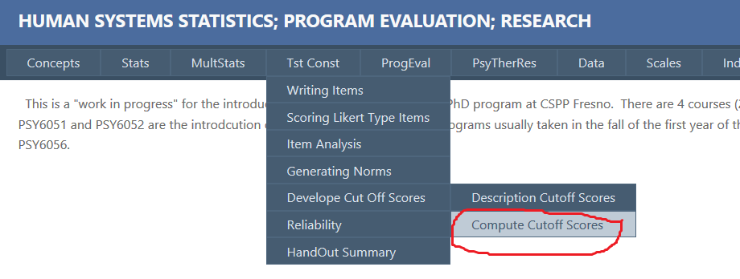

Brings up this window.
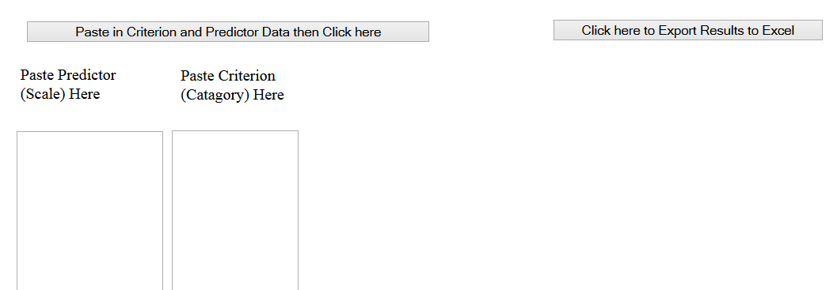
In this instance the predictor variable is the score on the subtext anxiety or “mAnx” and can be copied from the excel file or the spss file. The example below is the excel file all of the data in the column mAnx is selected and pasted in the “Paste Criterion (Category) Here” box.
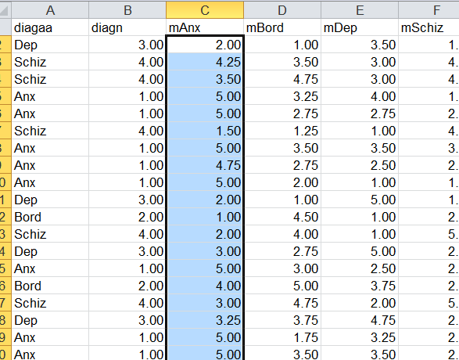

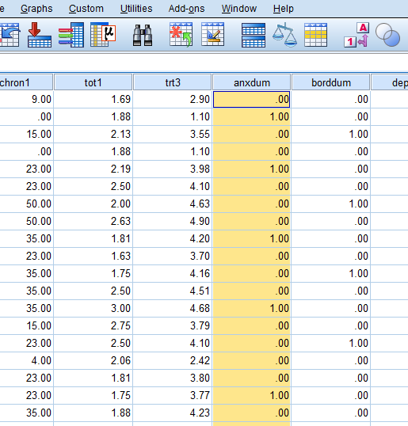
The mAnx data is copied from the excel file above and pasted in the “Paste Criterion (category) Here” box below.
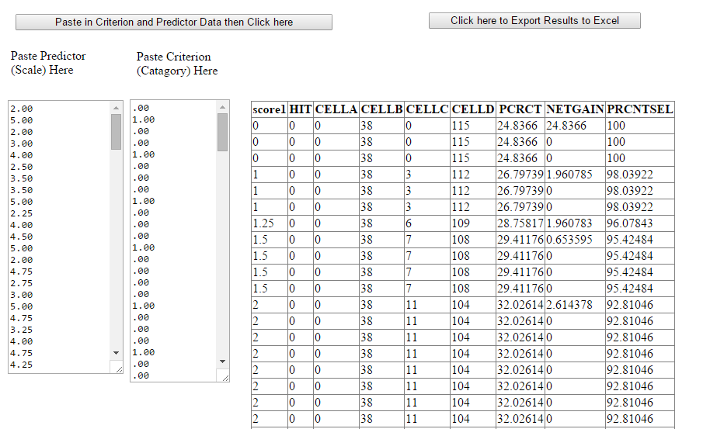

The “mAnx” data is then pasted in the “Paste Predictor (Scale) Here” in the same manner as the diagn above. Then the button “Paste in Criterion and Predictor Data and Click here” and the following screen appears.

Then click on the button “Click here to Export the Results to Excel” to obtain the results.
This window will appear – click OK.
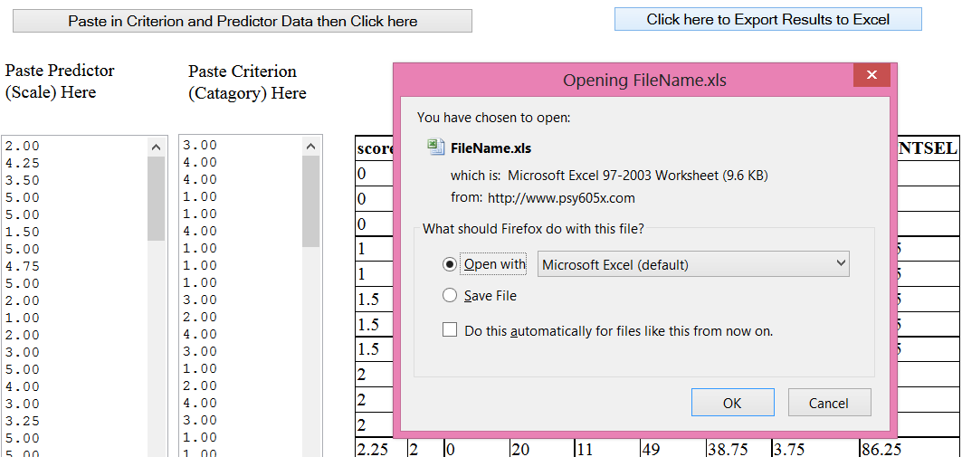

This pop up will appear click yes.
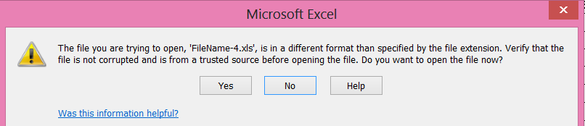
And your results will appear in an excel file called “Filename-?.xls”. The question mark represents some number depending on how many runs you have made. You results will look something like this.
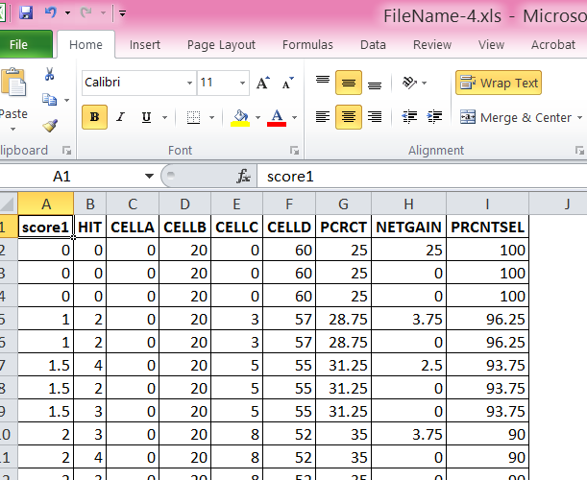
Go here for a description of the results.
