Structural Equation Modeling

Chapter 5

Confirmatory Factor Analysis

Merle Canfield

Structural Equation Modeling (SEM) solves problems in the following three areas:
1. Confirmatory factor analysis
2. Tests relationships within systems
a. test any single relationship within a system -- either measured or latent variables
b. tests the relationship of any number of independent variable with any number of dependent variables.
c. tests the effect of intervening variables -- either measured or latent variables
- Tests any within relationship across systems or groups
- Solves multi-trait multi-method analysis

SETTING QUESTIONNAIRE

NAME ________________________________________ DATE ___________________

SETTING _____________________________________ TIME ___________________

INSTRUCTIONS: For each item draw a circle around the number that you think best describes the setting according to the following scale.
none of a little of some of a lot of all of
the time the time the time the time the time
0 1 2 3 4 5 6 7 8
IMPORTANT: If you think that some people are acting or feeling one way and other people are acting or feeling another way then both may be circled. Two numbers may be cirecled for one item. Do not circle more than two. Try hard to circle only one.

When people are in this setting they are:

1. 0 1 2 3 4 5 6 7 8 tense
2. 0 1 2 3 4 5 6 7 8 satisfied
3. 0 1 2 3 4 5 6 7 8 easy going
4. 0 1 2 3 4 5 6 7 8 caring
5. 0 1 2 3 4 5 6 7 8 good
6. 0 1 2 3 4 5 6 7 8 friendly
7. 0 1 2 3 4 5 6 7 8 confident
8. 0 1 2 3 4 5 6 7 8 suspicious
9. 0 1 2 3 4 5 6 7 8 lazy
10. 0 1 2 3 4 5 6 7 8 forced to do things
11. 0 1 2 3 4 5 6 7 8 busy
12. 0 1 2 3 4 5 6 7 8 ordered around

When people are in this setting they:

13. 0 1 2 3 4 5 6 7 8 have a say about what to do
14. 0 1 2 3 4 5 6 7 8 share
15. 0 1 2 3 4 5 6 7 8 know what's going on
16. 0 1 2 3 4 5 6 7 8 think
17. 0 1 2 3 4 5 6 7 8 work together
18. 0 1 2 3 4 5 6 7 8 have high self-esteem
19. 0 1 2 3 4 5 6 7 8 learn
20. 0 1 2 3 4 5 6 7 8 joke around
21. 0 1 2 3 4 5 6 7 8 can come and go as they want
22. 0 1 2 3 4 5 6 7 8 talk about personal problems
23. 0 1 2 3 4 5 6 7 8 have a good time

In this setting:

24. 0 1 2 3 4 5 6 7 8 things get done
25. 0 1 2 3 4 5 6 7 8 its easy to fit in
26. 0 1 2 3 4 5 6 7 8 there is conflict
27. 0 1 2 3 4 5 6 7 8 people like each other 1-14-91
FACTOR ANALYSIS

In this next section comparisons are made between exploratory factor analysis of SPSS and confirmatory factor analysis.

File Name = pssfac1.sps
Get file = '\eqsw\psse.sav'.
missing values tense to peopleli (9).
FACTOR
/VARIABLES tense satisf easygo caring friendly confiden suspicio lazy
forced busy ordered whattodo share goingon think worktoge selfeste learn
joke comeandg personal goodtime thingsge easyfit conflict peopleli
/MISSING PAIRWISE`
/ANALYSIS tense satisf easygo caring friendly confiden suspicio lazy
forced busy ordered whattodo share goingon think worktoge selfeste learn
joke comeandg personal goodtime thingsge easyfit conflict peopleli
/PRINT UNIVARIATE INITIAL EXTRACTION rotation
/format blank(.6)
/CRITERIA MINEIGEN(1) ITERATE(25)
/EXTRACTION PC
/ROTATIOn.
`

F
Variable Communality * Factor Eigenvalue Pct of Var Cum Pct
*
TENSE .68622 * 1 7.95904 30.6 30.6
SATISF .61474 * 2 2.92423 11.2 41.9
EASYGO .61856 * 3 2.28513 8.8 50.6
CARING .59762 * 4 1.86620 7.2 57.8
FRIENDLY .73544 * 5 1.45179 5.6 63.4
CONFIDEN .74227 *
SUSPICIO .60471 *
LAZY .54658 *
FORCED .71548 *
BUSY .51481 *
ORDERED .73169 *
WHATTODO .63276 *
SHARE .63761 *
GOINGON .64061 *
THINK .56746 *
WORKTOGE .64044 *
SELFESTE .72203 *
LEARN .66384 *
JOKE .65242 *
COMEANDG .53249 *
PERSONAL .56356 *
GOODTIME .69280 *
THINGSGE .62281 *
EASYFIT .57819 *
CONFLICT .61912 *
PEOPLELI .61214 *

Rotated Factor Matrix:

Factor 1 Factor 2 Factor 3 Factor 4 Factor 5

TENSE -.33748 .14280 -.55715 .48508 -.07879
SATISF -.10956 .10454 .23999 -.08122 .72637
EASYGO .60898 -.06733 .40856 -.26744 .06872
CARING .41264 .42315 .35221 -.22366 .27243
FRIENDLY .73746 .24692 .26568 -.20259 .13784
CONFIDEN .20383 .08850 .80673 -.11233 .17165
SUSPICIO -.17217 -.00302 -.40997 .62799 .11234
LAZY .38514 -.21026 -.27895 .52351 .04646
FORCED -.07370 .09522 -.17503 .71404 -.40061
BUSY .06817 .44101 .35796 .30636 -.30607
ORDERED -.24153 -.07265 -.00696 .79561 -.18716
WHATTODO .32533 .14953 .21303 -.16149 .65810
SHARE .46952 .47672 .20995 -.09486 .36990
GOINGON .08950 .32857 .63821 -.10650 .32556
THINK .09479 .70307 .03687 -.17334 .18099
WORKTOGE .16038 .62811 .46726 -.03888 .01871
SELFESTE .25979 .17630 .76558 -.13892 .13434
LEARN .16265 .77897 -.05044 .00943 .16717
JOKE .79861 -.04793 .09651 .03903 .03881
COMEANDG .35468 -.36032 .31818 -.08393 .41059
PERSONAL .21173 .15159 -.04151 .26340 .65165
GOODTIME .81444 .10325 .11005 .00718 .08164
THINGSGE .04663 .77111 .13153 .08672 -.03468
EASYFIT .63744 .24072 .16952 -.28043 .08087
CONFLICT -.16478 -.03841 .01547 .70791 .29852
PEOPLELI .71516 .27418 .07419 -.13461 .04348

Rotated Factor Matrix:

Factor 1 Factor 2 Factor 3 Factor 4 Factor 5

TENSE
SATISF .72637
EASYGO .60898
CARING
FRIENDLY .73746
CONFIDEN .80673
SUSPICIO .62799
LAZY
FORCED .71404
BUSY
ORDERED .79561
WHATTODO .65810
SHARE
GOINGON .63821
THINK .70307
WORKTOGE .62811
SELFESTE .76558
LEARN .77897
JOKE .79861
COMEANDG
PERSONAL .65165
GOODTIME .81444
THINGSGE .77111
EASYFIT .63744
CONFLICT .70791
PEOPLELI .71516

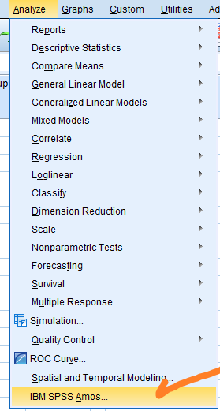

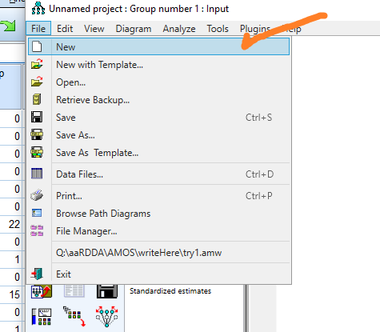

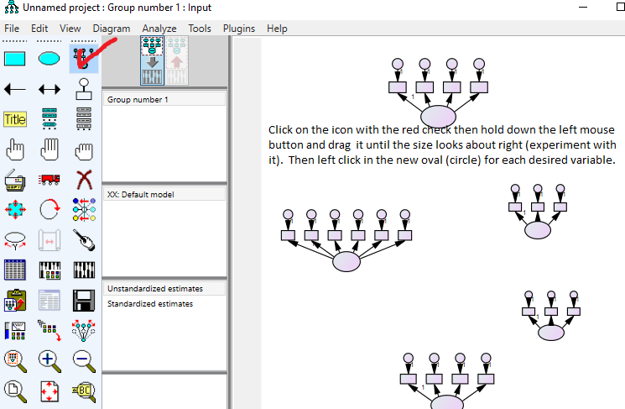

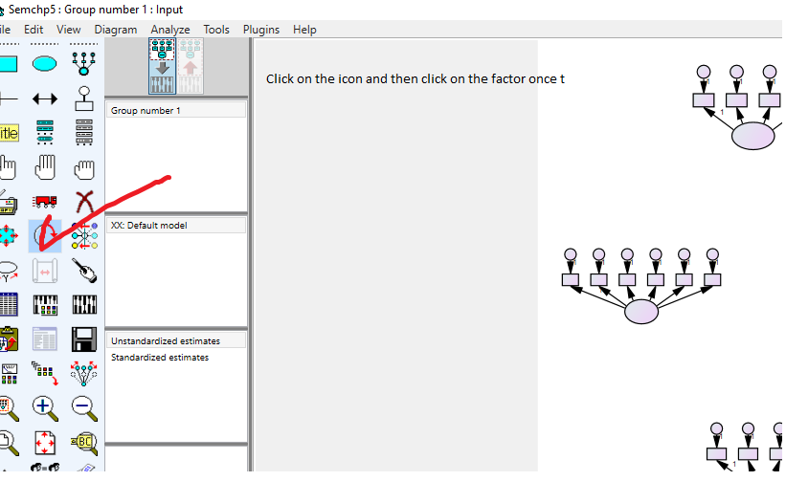

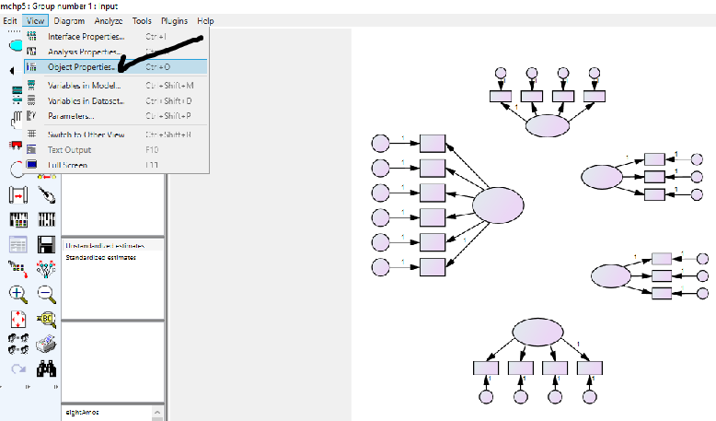

Then name the factors, measured variables, and error. First click on a factor or variable and then select view.

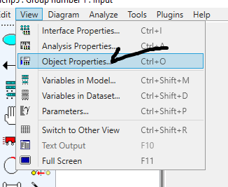

The type the name of the factor, variable or error in the variable name box.

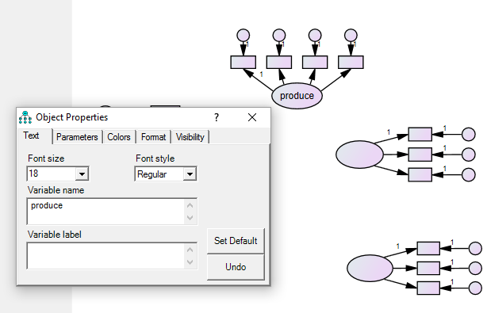

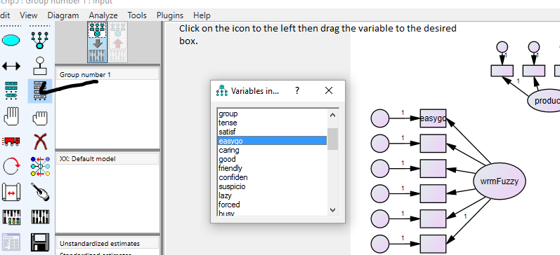

Do em all.

Then back to “Object Properties” to name the error variables.

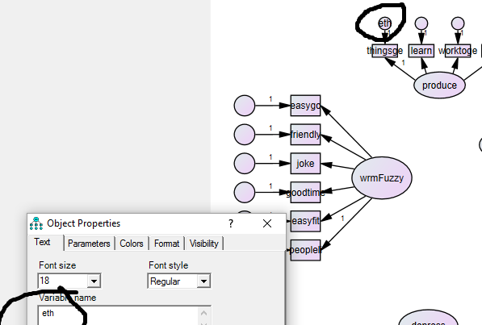

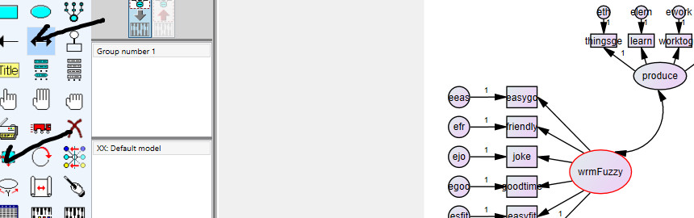

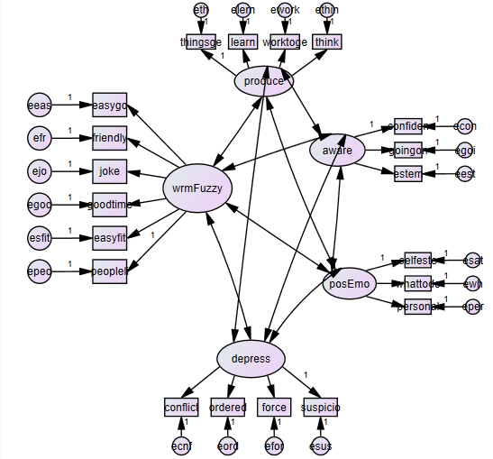

The model ready to run.

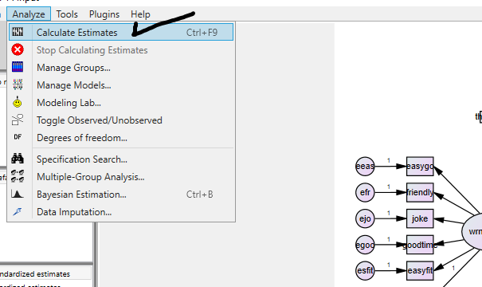

Decide what parameters are desired.

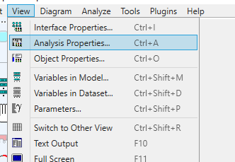

Start with these.

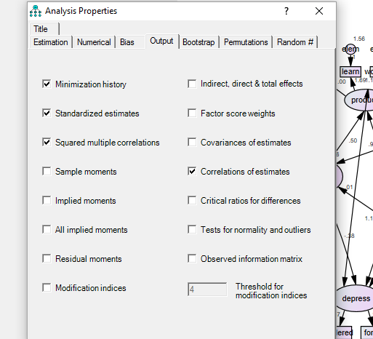

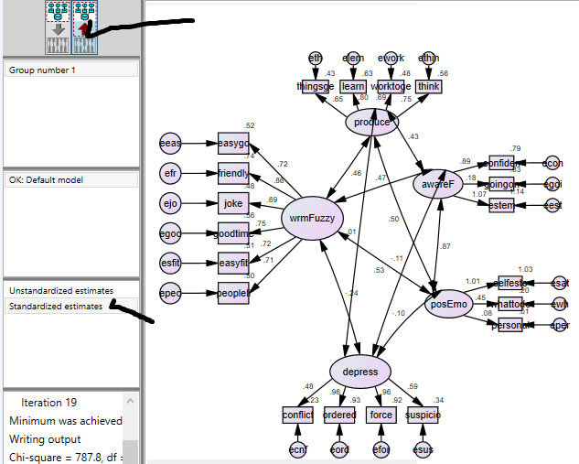

These values are regression coefficients – standardized beta weights – like correlations (sometimes called correlations). But not correlations – notice that some are greater than 1.

File Name = psscon1.eqs
/TITLE
Confirmatory Factor Analysis --- Setting 5 Factors
/SPECIFICATIONS
!DATA='C:\EQSW\PSSMAT1.ESS'; VARIABLES= 20; CASES= 268;
VARIABLES= 20; CASES= 268;
METHODS=ML;
MATRIX=COVARIANCE;
/LABELS
V1=SATISF; V2=EASYGO; V3=FRIENDLY; V4=CONFIDEN; V5=SUSPICIO;
V6=FORCED; V7=ORDERED; V8=WHATTODO; V9=GOINGON; V10=THINK;
V11=WORKTOGE; V12=SELFESTE; V13=LEARN; V14=JOKE; V15=PERSONAL;
V16=GOODTIME; V17=THINGSGE; V18=EASYFIT; V19=CONFLICT; V20=PEOPLELI;
V16=GOODTIME; V17=THINGSGE; V18=EASYFIT; V19=CONFLICT; V20=PEOPLELI;
/EQUATIONS
V1 = + *F5 + E1;
V2 = + *F1 + E2;
V3 = + *F1 + E3;
V4 = + *F3 + E4;
V5 = + *F4 + E5;
V6 = + *F4 + E6;
V7 = + *F4 + E7;
V9 = + *F3 + E9;
V10 = + *F2 + E10;
V11 = + *F2 + E11;
V12 = + *F3 + E12;
V13 = + *F2 + E13;
V14 = + *F1 + E14;
V15 = + *F5 + E15;
V16 = + *F1 + E16;
V17 = + *F2 + E17;
V18 = + *F1 + E18;
V19 = + *F4 + E19;
V20 = + *F1 + E20;
/VARIANCES
F1 = 1.00;
F2 = 1.00;
F3 = 1.00;
F4 = 1;
F5 = 1;
E1 = *;
E2 = *;
E3 = *;
E4 = *;
E5 = *;
E6 = *;
E7 = *;
E9 = *;
E10 = *;
E11 = *;
E12 = *;
E13 = *;
E14 = *;
E15 = *;
E16 = *;
E17 = *;
E18 = *;
E19 = *;
E20 = *;
/COVARIANCES
F1 , f2 = *;
F1 , f3 = *;
F1 , F4 = *;
F1 , f5 = *;
F2 , F3 = *;
F2 , F4 = *;
F2 , f5 = *;
F3 , F4 = *;
F3 , F5 = *;
F4 , F5 = *;
/OUTPUT
parameters;
standard errors;
listing;
data='EQSOUT&.ETS';
/MATRIX
4.710
0.691 3.306
0.617 1.894 2.545
1.294 1.570 1.362 3.596
-0.086 -1.164 -1.025 -1.722 5.083
-1.577 -1.198 -0.940 -1.333 2.200 5.043
-0.572 -1.357 -1.190 -0.584 2.261 3.152 4.298
1.778 1.187 1.216 1.353 -0.640 -1.660 -1.494
3.677
1.179 1.144 1.031 1.769 -1.100 -1.114 -0.781
1.567 3.043
0.492 0.285 0.659 0.722 -0.616 -0.486 -0.703
0.770 0.955 2.596
0.470 0.733 0.951 1.204 -0.701 -0.359 -0.401
0.629 1.345 0.996 2.382
1.012 1.641 1.289 2.557 -1.799 -1.223 -0.789
1.431 1.794 0.951 1.341 3.449
0.890 0.281 0.889 0.442 0.019 0.051 -0.395
0.886 0.839 2.085 1.396 1.042 3.949
-0.098 1.709 1.623 0.743 -0.652 -0.521 -0.718
1.033 0.561 0.190 0.522 0.923 0.483 3.412
1.899 0.093 0.818 0.445 0.384 -0.090 0.279
1.398 0.919 0.424 0.623 0.160 0.987 0.775
5.045
0.229 1.732 1.795 1.022 -0.891 -0.518 -0.877
1.380 0.750 0.349 0.688 1.171 1.158 2.458
1.091 3.720
0.192 0.065 0.498 0.404 0.006 0.232 -0.143
0.435 0.814 0.924 1.090 0.517 1.413 0.069
0.335 0.472 2.027
0.261 1.291 1.568 1.107 -1.384 -1.188 -1.161
1.256 0.810 0.760 0.743 1.236 0.810 1.315
0.535 1.675 0.562 2.692
0.417 -1.016 -0.642 -0.340 1.765 1.246 1.644
0.006 -0.108 -0.338 -0.330 -0.467 -0.130 -0.170
0.998 -0.371 0.241 -0.720 3.687
0.371 1.221 1.663 0.891 -0.885 -0.441 -0.958
0.873 0.510 0.671 0.683 0.788 0.713 1.255
0.638 1.681 0.518 1.405 -0.479 2.405
/END

E1 = *;
E2 = *;
E3 = *;
E4 = *;
E5 = *;
E6 = *;
E7 = *;
E9 = *;
E10 = *;
E11 = *;
E12 = *;
E13 = *;
E14 = *;
E15 = *;
E16 = *;
E17 = *;
E18 = *;
E19 = *;
E20 = *;
/COVARIANCES
F1 , f2 = *;
F1 , f3 = *;
F1 , F4 = *;
F1 , f5 = *;
F2 , F3 = *;
F2 , F4 = *;
F2 , f5 = *;
F3 , F4 = *;
F3 , F5 = *;
F4 , F5 = *;
/OUTPUT
parameters;
standard errors;
listing;
data='EQSOUT&.ETS';
/MATRIX
4.710
0.691 3.306
0.617 1.894 2.545
1.294 1.570 1.362 3.596
-0.086 -1.164 -1.025 -1.722 5.083
-1.577 -1.198 -0.940 -1.333 2.200 5.043
-0.572 -1.357 -1.190 -0.584 2.261 3.152 4.298
1.778 1.187 1.216 1.353 -0.640 -1.660 -1.494
3.677 1.179 1.144 1.031 1.769 -1.100 -1.114 -0.781
1.567 3.043
0.492 0.285 0.659 0.722 -0.616 -0.486 -0.703
0.770 0.955 2.596
0.470 0.733 0.951 1.204 -0.701 -0.359 -0.401
0.629 1.345 0.996 2.382
1.012 1.641 1.289 2.557 -1.799 -1.223 -0.789
1.431 1.794 0.951 1.341 3.449
0.890 0.281 0.889 0.442 0.019 0.051 -0.395
0.886 0.839 2.085 1.396 1.042 3.949
-0.098 1.709 1.623 0.743 -0.652 -0.521 -0.718
1.033 0.561 0.190 0.522 0.923 0.483 3.412
1.899 0.093 0.818 0.445 0.384 -0.090 0.279
1.398 0.919 0.424 0.623 0.160 0.987 0.775
5.045
0.229 1.732 1.795 1.022 -0.891 -0.518 -0.877
1.380 0.750 0.349 0.688 1.171 1.158 2.458
1.091 3.720
0.192 0.065 0.498 0.404 0.006 0.232 -0.143
0.435 0.814 0.924 1.090 0.517 1.413 0.069
0.335 0.472 2.027
0.261 1.291 1.568 1.107 -1.384 -1.188 -1.161
1.256 0.810 0.760 0.743 1.236 0.810 1.315
0.535 1.675 0.562 2.692
0.417 -1.016 -0.642 -0.340 1.765 1.246 1.644
0.006 -0.108 -0.338 -0.330 -0.467 -0.130 -0.170
0.998 -0.371 0.241 -0.720 3.687
0.371 1.221 1.663 0.891 -0.885 -0.441 -0.958
0.873 0.510 0.671 0.683 0.788 0.713 1.255
0.638 1.681 0.518 1.405 -0.479 2.405
/END

IN ITERATION # 1,MATRIX W_CFUNCT MAY NOT BE POSITIVE DEFINITE

YOU HAVE BAD START VALUES TO BEGIN WITH.
IF ABOVE MESSAGE APPEARS ON EVERY ITERATION, PLEASE PROVIDE BETTER START VALUES AND RE-RUN THE JOB.

TITLE: Confirmatory Factor Analysis --- Setting 5 Factors PAGE : 6
EQS is not installed or unauthorized copy
MAXIMUM LIKELIHOOD SOLUTION (NORMAL DISTRIBUTION THEORY)

PARAMETER CONDITION CODE
E1,E1 CONSTRAINED AT LOWER BOUND
LARGEST STANDARDIZED RESIDUALS:

V 11,V 9 V 19,V 15 V 12,V 5 V 12,V 11 V 16,V 15
0.303 0.267 -0.224 0.211 0.210

V 5,V 4 V 16,V 14 V 13,V 4 V 19,V 1 V 18,V 5
-0.207 0.198 -0.193 0.192 -0.180

V 15,V 3 V 6,V 1 V 11,V 4 V 11,V 3 V 15,V 13
0.178 -0.171 0.166 0.164 0.155

V 17,V 2 V 13,V 2 V 15,V 14 V 17,V 6 V 15,V 9
-0.152 -0.152 0.148 0.147 0.145

*** WARNING *** TEST RESULTS MAY NOT BE APPROPRIATE DUE TO CONDITION CODE

GOODNESS OF FIT SUMMARY

INDEPENDENCE MODEL CHI-SQUARE = 2535.891 ON 171 DEGREES OF FREEDOM

INDEPENDENCE AIC = 2193.89135 INDEPENDENCE CAIC = 1408.83258
MODEL AIC = 356.74483 MODEL CAIC = -295.17532

CHI-SQUARE = 640.745 BASED ON 142 DEGREES OF FREEDOM
PROBABILITY VALUE FOR THE CHI-SQUARE STATISTIC IS LESS THAN 0.001
THE NORMAL THEORY RLS CHI-SQUARE FOR THIS ML SOLUTION IS 617.906.

BENTLER-BONETT NORMED FIT INDEX= 0.747
BENTLER-BONETT NONNORMED FIT INDEX= 0.746
COMPARATIVE FIT INDEX = 0.789

TITLE: Confirmatory Factor Analysis --- Setting 5 Factors PAGE : 17
EQS is not installed or unauthorized copy
MAXIMUM LIKELIHOOD SOLUTION (NORMAL DISTRIBUTION THEORY)

STANDARDIZED SOLUTION:

SATISF =V1 = 1.000*F5 + .000 E1
EASYGO =V2 = .708*F1 + .707 E2
FRIENDLY=V3 = .868*F1 + .496 E3
CONFIDEN=V4 = .826*F3 + .564 E4
SUSPICIO=V5 = .603*F4 + .798 E5
FORCED =V6 = .774*F4 + .633 E6
ORDERED =V7 = .848*F4 + .531 E7
GOINGON =V9 = .662*F3 + .750 E9
THINK =V10 = .733*F2 + .680 E10
WORKTOGE=V11 = .635*F2 + .772 E11
SELFESTE=V12 = .864*F3 + .503 E12
LEARN =V13 = .804*F2 + .594 E13
JOKE =V14 = .670*F1 + .742 E14
PERSONAL=V15 = .390*F5 + .921 E15
GOODTIME=V16 = .734*F1 + .679 E16
THINGSGE=V17 = .621*F2 + .784 E17
EASYFIT =V18 = .704*F1 + .711 E18
CONFLICT=V19 = .467*F4 + .884 E19
PEOPLELI=V20 = .730*F1 + .683 E20

Original | Original Squared | 1 minus squared
0 | 0 | 1
0.707 | 0.499849 | 0.500151
0.496 | 0.246016 | 0.753984
0.564 | 0.318096 | 0.681904
0.798 | 0.636804 | 0.363196
0.633 | 0.400689 | 0.599311
0.531 | 0.281961 | 0.718039
0.75 | 0.5625 | 0.4375
0.68 | 0.4624 | 0.5376
0.772 | 0.595984 | 0.404016
0.503 | 0.253009 | 0.746991
0.594 | 0.352836 | 0.647164
0.742 | 0.550564 | 0.449436
0.921 | 0.848241 | 0.151759
0.679 | 0.461041 | 0.538959
0.784 | 0.614656 | 0.385344
0.711 | 0.505521 | 0.494479
0.884 | 0.781456 | 0.218544
0.683 | 0.466489 | 0.533511
Sum |  | 10.16189
Sum  Divided  by 19 |  | 0.534836

The percentage of variance accounted is computed by squaring the error coefficient, subtracting that from 1, summing that and dividing by the number of equations. The "1 MINUS" is the variance accounted for by the variable (R squared). The sum of the column divided by the number reprsents the variance accounted for by the five factors. This can be compared to the variance accounted for by the explatory factor analysis.

CORRELATIONS AMONG INDEPENDENT VARIABLES
---------------------------------------

V F
--- ---
I F2 - F2 .403*I
I F1 - F1 I
I I
I F3 - F3 .576*I
I F1 - F1 I
I I
I F4 - F4 -.457*I
I F1 - F1 I
I I
I F5 - F5 .148*I
I F1 - F1 I
I I
I F3 - F3 .467*I
I F2 - F2 I
I I
I F4 - F4 -.154*I
I F2 - F2 I
I I
I F5 - F5 .211*I
I F2 - F2 I
I I
I F4 - F4 -.394*I
I F3 - F3 I
I I
I F5 - F5 .347*I
I F3 - F3 I
I I
I F5 - F5 -.197*I
I F4 - F4 I
I I

File Name = psscon2.eqs

/TITLE
Setting --- 4 Factors
/SPECIFICATIONS
!DATA='C:\EQSW\PSSMAT1.ESS'; VARIABLES= 20; CASES= 268;
VARIABLES= 20; CASES= 268;
METHODS=ML;
MATRIX=COVARIANCE;
/LABELS
V1=SATISF; V2=EASYGO; V3=FRIENDLY; V4=CONFIDEN; V5=SUSPICIO;
V6=FORCED; V7=ORDERED; V8=WHATTODO; V9=GOINGON; V10=THINK;
V11=WORKTOGE; V12=SELFESTE; V13=LEARN; V14=JOKE; V15=PERSONAL;
V16=GOODTIME; V17=THINGSGE; V18=EASYFIT; V19=CONFLICT; V20=PEOPLELI;
V16=GOODTIME; V17=THINGSGE; V18=EASYFIT; V19=CONFLICT; V20=PEOPLELI;
/lmtest
/EQUATIONS
V2 = + *F1 + E2;
V3 = + *F1 + E3;
V4 = + *F3 + E4;
V5 = + *F4 + E5;
V6 = + *F4 + E6;
V7 = + *F4 + E7;
V9 = + *F3 + E9;
V10 = + *F2 + E10;
V11 = + *F2 + E11;
V12 = + *F3 + E12;
V13 = + *F2 + E13;
V14 = + *F1 + E14;
V16 = + *F1 + E16;
V17 = + *F2 + E17;
V18 = + *F1 + E18;
V19 = + *F4 + E19;
V20 = + *F1 + E20;
/VARIANCES
F1 = *;
F2 = *;
F3 = *;
F4 = *;
E2 = *;
E3 = *;
E4 = *;
E5 = *;
E6 = *;
E7 = *;
E9 = *;
E10 = *;E11 = *;
E12 = *;
E13 = *;
E14 = *;
E16 = *;
E17 = *;
E18 = *;
E19 = *;
E20 = *;
/COVARIANCES
F2 , F1 = *;
F3 , F1 = *;
F3 , F2 = *;
F4 , F1 = *;
F4 , F2 = *;
F4 , F3 = *;

E7 = *;
E9 = *;
E10 = *;
E11 = *;
E12 = *;
E13 = *;
E14 = *;
E16 = *;
E17 = *;
E18 = *;
E19 = *;
E20 = *;
/COVARIANCES
F2 , F1 = *;
F3 , F1 = *;
F3 , F2 = *;
F4 , F1 = *;
F4 , F2 = *;
F4 , F3 = *;

MAXIMUM LIKELIHOOD SOLUTION (NORMAL DISTRIBUTION THEORY)

PARAMETER CONDITION CODE
V4,F3 LINEARLY DEPENDENT ON OTHER PARAMETERS
V5,F4 LINEARLY DEPENDENT ON OTHER PARAMETERS
V17,F2 LINEARLY DEPENDENT ON OTHER PARAMETERS
V20,F1 LINEARLY DEPENDENT ON OTHER PARAMETERS
MAXIMUM LIKELIHOOD SOLUTION (NORMAL DISTRIBUTION THEORY)
V17,F2 VARIANCE OF PARAMETER ESTIMATE IS SET TO ZERO.
V20,F1 VARIANCE OF PARAMETER ESTIMATE IS SET TO ZERO.

GOODNESS OF FIT SUMMARY

INDEPENDENCE MODEL CHI-SQUARE = 2315.765 ON 136 DEGREES OF FREEDOM

INDEPENDENCE AIC = 2043.76481 INDEPENDENCE CAIC = 1419.39058
MODEL AIC = 279.53349 MODEL CAIC = -220.88409

CHI-SQUARE = 497.533 BASED ON 109 DEGREES OF FREEDOM
PROBABILITY VALUE FOR THE CHI-SQUARE STATISTIC IS LESS THAN 0.001
THE NORMAL THEORY RLS CHI-SQUARE FOR THIS ML SOLUTION IS 471.639.

BENTLER-BONETT NORMED FIT INDEX= 0.785
BENTLER-BONETT NONNORMED FIT INDEX= 0.778
COMPARATIVE FIT INDEX = 0.822

STANDARDIZED SOLUTION:

EASYGO =V2 = .708*F1 + .706 E2
FRIENDLY=V3 = .869*F1 + .495 E3

CONFIDEN=V4 = .816*F3 + .578 E4
SUSPICIO=V5 = .609*F4 + .793 E5
FORCED =V6 = .765*F4 + .644 E6
ORDERED =V7 = .850*F4 + .527 E7
GOINGON =V9 = .653*F3 + .758 E9
THINK =V10 = .733*F2 + .681 E10
WORKTOGE=V11 = .641*F2 + .767 E11
SELFESTE=V12 = .879*F3 + .477 E12
LEARN =V13 = .797*F2 + .604 E13
JOKE =V14 = .669*F1 + .743 E14
GOODTIME=V16 = .733*F1 + .680 E16
THINGSGE=V17 = .624*F2 + .781 E17
EASYFIT =V18 = .703*F1 + .711 E18
CONFLICT=V19 = .475*F4 + .880 E19
PEOPLELI=V20 = .730*F1 + .683 E20
CORRELATIONS AMONG INDEPENDENT VARIABLES
---------------------------------------

V F
--- ---
I F2 - F2 .405*I
I F1 - F1 I
I I
I F3 - F3 .574*I
I F1 - F1 I
I I
I F4 - F4 -.459*I
I F1 - F1 I
I I
I F3 - F3 .473*I
I F2 - F2 I
I I
I F4 - F4 -.158*I
I F2 - F2 I
I I
I F4 - F4 -.391*I
I F3 - F3 I
I I

MULTIVARIATE LAGRANGE MULTIPLIER TEST BY SIMULTANEOUS PROCESS IN STAGE 1

PARAMETER SETS (SUBMATRICES) ACTIVE AT THIS STAGE ARE:

PVV PFV PFF PDD GVV GVF GFV GFF BVF BFF

CUMULATIVE MULTIVARIATE STATISTICS UNIVARIATE INCREMENT
---------------------------------- --------------------

STEP PARAMETER CHI-SQUARE D.F. PROBABILITY CHI-SQUARE PROBABILITY
---- ----------- ---------- ---- ----------- ---------- -----------

1 V11,F3 39.399 1 0.000 39.399 0.000
2 V5,F3 67.570 2 0.000 28.171 0.000
3 V2,F3 82.922 3 0.000 15.352 0.000
4 V2,F2 104.836 4 0.000 21.914 0.000
5 V10,F4 117.324 5 0.000 12.488 0.000
6 V9,F2 129.503 6 0.000 12.179 0.000
7 V14,F2 140.544 7 0.000 11.040 0.001
8 V18,F4 150.153 8 0.000 9.610 0.002
9 V7,F3 157.533 9 0.000 7.380 0.007

10 V4,F2 163.976 10 0.000 6.442 0.011
11 V6,F1 170.069 11 0.000 6.093 0.014
12 V14,F4 174.994 12 0.000 4.925 0.026
13 V16,F4 180.921 13 0.000 5.927 0.015
14 V20,F3 186.048 14 0.000 5.127 0.024

File Name = psscon3.eqs

/TITLE
Setting --- 4 Factors
/SPECIFICATIONS
!DATA='C:\EQSW\PSSMAT1.ESS'; VARIABLES= 20; CASES= 268;
VARIABLES= 20; CASES= 268;
METHODS=ML;
MATRIX=COVARIANCE;
/LABELS
V1=SATISF; V2=EASYGO; V3=FRIENDLY; V4=CONFIDEN; V5=SUSPICIO;
V6=FORCED; V7=ORDERED; V8=WHATTODO; V9=GOINGON; V10=THINK;
V11=WORKTOGE; V12=SELFESTE; V13=LEARN; V14=JOKE; V15=PERSONAL;
V16=GOODTIME; V17=THINGSGE; V18=EASYFIT; V19=CONFLICT; V20=PEOPLELI;
V16=GOODTIME; V17=THINGSGE; V18=EASYFIT; V19=CONFLICT; V20=PEOPLELI;
/lmtest
/EQUATIONS
V2 = + *F1 + *f3 + E2;
V3 = + *F1 + E3;
V4 = + *F3 + E4;
V6 = + *F4 + E6;
V7 = + *F4 + E7;
V9 = + *F3 + E9;
V10 = + *F2 + E10;
V11 = + *F2 + *f3 + E11;
V12 = + *F3 + E12;
V13 = + *F2 + E13;
V14 = + *F1 + E14;
V16 = + *F1 + E16;
V17 = + *F2 + E17;
V18 = + *F1 + E18;
V20 = + *F1 + E20;
/VARIANCES
F1 = 1;
F2 = 1;
F3 = 1;
F4 = 1;

E2 = *;
E3 = *;
E4 = *;
E5 = *;
E6 = *;
E7 = *;
E9 = *;
E10 = *;
E11 = *;
E12 = *;
E13 = *;
E14 = *;
E16 = *;
E17 = *;
E18 = *;
E20 = *;
/COVARIANCES
F2 , F1 = *;
F3 , F1 = *;
F3 , F2 = *;
F4 , F1 = *;
F4 , F2 = *;
F4 , F3 = *;
/OUTPUT
parameters;
standard errors;
listing;
data='EQSOUT&.ETS';
/MATRIX
4.710
0.691 3.306
0.617 1.894 2.545
1.294 1.570 1.362 3.596
-0.086 -1.164 -1.025 -1.722 5.083
-1.577 -1.198 -0.940 -1.333 2.200 5.043
-0.572 -1.357 -1.190 -0.584 2.261 3.152 4.298
1.778 1.187 1.216 1.353 -0.640 -1.660 -1.494
3.677
1.179 1.144 1.031 1.769 -1.100 -1.114 -0.781
1.567 3.043
0.492 0.285 0.659 0.722 -0.616 -0.486 -0.703
0.770 0.955 2.596
0.470 0.733 0.951 1.204 -0.701 -0.359 -0.401
0.629 1.345 0.996 2.382

1.012 1.641 1.289 2.557 -1.799 -1.223 -0.789
1.431 1.794 0.951 1.341 3.449
0.890 0.281 0.889 0.442 0.019 0.051 -0.395
0.886 0.839 2.085 1.396 1.042 3.949
-0.098 1.709 1.623 0.743 -0.652 -0.521 -0.718
1.033 0.561 0.190 0.522 0.923 0.483 3.412
1.899 0.093 0.818 0.445 0.384 -0.090 0.279
1.398 0.919 0.424 0.623 0.160 0.987 0.775
5.045
0.229 1.732 1.795 1.022 -0.891 -0.518 -0.877
1.380 0.750 0.349 0.688 1.171 1.158 2.458
1.091 3.720
0.192 0.065 0.498 0.404 0.006 0.232 -0.143
0.435 0.814 0.924 1.090 0.517 1.413 0.069
0.335 0.472 2.027
0.261 1.291 1.568 1.107 -1.384 -1.188 -1.161
1.256 0.810 0.760 0.743 1.236 0.810 1.315
0.535 1.675 0.562 2.692
0.417 -1.016 -0.642 -0.340 1.765 1.246 1.644
0.006 -0.108 -0.338 -0.330 -0.467 -0.130 -0.170
0.998 -0.371 0.241 -0.720 3.687
0.371 1.221 1.663 0.891 -0.885 -0.441 -0.958
0.873 0.510 0.671 0.683 0.788 0.713 1.255
0.638 1.681 0.518 1.405 -0.479 2.405
/END

1
MAXIMUM LIKELIHOOD SOLUTION (NORMAL DISTRIBUTION THEORY)

PARAMETER CONDITION CODE
E5,E5 CONSTRAINED AT LOWER BOUND
LARGEST STANDARDIZED RESIDUALS:

V 16,V 14 V 17,V 9 V 10,V 9 V 13,V 2 V 17,V 2
0.187 0.183 0.165 -0.164 -0.149

V 10,V 7 V 17,V 11 V 11,V 9 V 13,V 4 V 16,V 6
-0.148 0.144 0.137 -0.131 0.130

V 17,V 6 V 20,V 6 V 17,V 14 V 14,V 10 V 10,V 2
0.124 0.121 -0.120 -0.113 -0.113

V 18,V 7 V 18,V 10 V 14,V 6 V 7,V 2 V 7,V 4
-0.105 0.104 0.102 -0.099 0.097

GOODNESS OF FIT SUMMARY

INDEPENDENCE MODEL CHI-SQUARE = 2070.674 ON 105 DEGREES OF FREEDOM

INDEPENDENCE AIC = 1860.67397 INDEPENDENCE CAIC = 1378.62034
MODEL AIC = 176.12669 MODEL CAIC = -195.74325

CHI-SQUARE = 338.127 BASED ON 81 DEGREES OF FREEDOM
PROBABILITY VALUE FOR THE CHI-SQUARE STATISTIC IS LESS THAN 0.001
THE NORMAL THEORY RLS CHI-SQUARE FOR THIS ML SOLUTION IS 326.302.

BENTLER-BONETT NORMED FIT INDEX= 0.837
BENTLER-BONETT NONNORMED FIT INDEX= 0.830
COMPARATIVE FIT INDEX = 0.869

STANDARDIZED SOLUTION:

EASYGO =V2 = .555*F1 + .247*F3 + .694 E2
FRIENDLY=V3 = .865*F1 + .501 E3
CONFIDEN=V4 = .823*F3 + .568 E4
FORCED =V6 = .821*F4 + .570 E6
ORDERED =V7 = .824*F4 + .566 E7
GOINGON =V9 = .664*F3 + .748 E9
THINK =V10 = .737*F2 + .676 E10
WORKTOGE=V11 = .439*F2 + .389*F3 + .731 E11
SELFESTE=V12 = .868*F3 + .496 E12
LEARN =V13 = .848*F2 + .530 E13
JOKE =V14 = .677*F1 + .736 E14
GOODTIME=V16 = .743*F1 + .669 E16
THINGSGE=V17 = .609*F2 + .793 E17
EASYFIT =V18 = .702*F1 + .712 E18
PEOPLELI=V20 = .738*F1 + .675 E20

CORRELATIONS AMONG INDEPENDENT VARIABLES
---------------------------------------

V F
--- ---
I F2 - F2 .355*I
I F1 - F1 I
I I
I F3 - F3 .544*I
I F1 - F1 I
I I
I F4 - F4 -.409*I
I F1 - F1 I
I I
I F3 - F3 .357*I
I F2 - F2 I
I I
I F4 - F4 -.102*I
I F2 - F2 I
I I
I F4 - F4 -.361*I
I F3 - F3 I
I I

CUMULATIVE MULTIVARIATE STATISTICS UNIVARIATE INCREMENT
---------------------------------- --------------------

STEP PARAMETER CHI-SQUARE D.F. PROBABILITY CHI-SQUARE PROBABILITY
---- ----------- ---------- ---- ----------- ---------- -----------

1 V6,F1 29.284 1 0.000 29.284 0.000
2 V2,F2 50.843 2 0.000 21.559 0.000
3 V4,F2 64.476 3 0.000 13.632 0.000
4 V10,F4 75.834 4 0.000 11.358 0.001
5 V14,F2 85.934 5 0.000 10.100 0.001
6 V18,F4 94.355 6 0.000 8.421 0.004
7 V3,F3 103.523 7 0.000 9.168 0.002
8 V9,F2 107.417 8 0.000 3.894 0.048

File Name = psscon9.eqs

/TITLE
Setting --- 4 Factors
/SPECIFICATIONS
!DATA='C:\EQSW\PSSMAT1.ESS'; VARIABLES= 20; CASES= 268;
VARIABLES= 20; CASES= 268;
METHODS=ML;
MATRIX=COVARIANCE;
/LABELS
V1=SATISF; V2=EASYGO; V3=FRIENDLY; V4=CONFIDEN; V5=SUSPICIO;
V6=FORCED; V7=ORDERED; V8=WHATTODO; V9=GOINGON; V10=THINK;
V11=WORKTOGE; V12=SELFESTE; V13=LEARN; V14=JOKE; V15=PERSONAL;
V16=GOODTIME; V17=THINGSGE; V18=EASYFIT; V19=CONFLICT; V20=PEOPLELI;
V16=GOODTIME; V17=THINGSGE; V18=EASYFIT; V19=CONFLICT; V20=PEOPLELI;
/lmtest
/EQUATIONS
V2 = + *F1 + *f3 + *f2 + E2;
V3 = + *F1 + E3;
V4 = + *F3 + E4;
V6 = + *F4 + E6;
V7 = + *F4 + E7;
V10 = + *F2 + E10;
V12 = + *F3 + E12;
V13 = + *F2 + E13;
V16 = + *F1 + E16;
V18 = + *F1 + E18;
V20 = + *F1 + E20;
/VARIANCES
F1 = 1;
F2 = 1;
F3 = 1;

F4 = 1;
E2 = *;
E3 = *;
E4 = *;
E6 = *;
E7 = *;
E10 = *;
E12 = *;
E13 = *;
E16 = *;
E18 = *;
E20 = *;
/COVARIANCES
F2 , F1 = *;
F3 , F1 = *;
F3 , F2 = *;
F4 , F1 = *;
F4 , F2 = *;
F4 , F3 = *;
/OUTPUT
parameters;
standard errors;
listing;
data='EQSOUT&.ETS';
/MATRIX
4.710
0.691 3.306
0.617 1.894 2.545
1.294 1.570 1.362 3.596
-0.086 -1.164 -1.025 -1.722 5.083
-1.577 -1.198 -0.940 -1.333 2.200 5.043
-0.572 -1.357 -1.190 -0.584 2.261 3.152 4.298
1.778 1.187 1.216 1.353 -0.640 -1.660 -1.494
3.677
1.179 1.144 1.031 1.769 -1.100 -1.114 -0.781
1.567 3.043
0.492 0.285 0.659 0.722 -0.616 -0.486 -0.703
0.770 0.955 2.596
0.470 0.733 0.951 1.204 -0.701 -0.359 -0.401
0.629 1.345 0.996 2.382
1.012 1.641 1.289 2.557 -1.799 -1.223 -0.789
1.431 1.794 0.951 1.341 3.449
0.890 0.281 0.889 0.442 0.019 0.051 -0.395
0.886 0.839 2.085 1.396 1.042 3.949

-0.098 1.709 1.623 0.743 -0.652 -0.521 -0.718
1.033 0.561 0.190 0.522 0.923 0.483 3.412
1.899 0.093 0.818 0.445 0.384 -0.090 0.279
1.398 0.919 0.424 0.623 0.160 0.987 0.775
5.045
0.229 1.732 1.795 1.022 -0.891 -0.518 -0.877
1.380 0.750 0.349 0.688 1.171 1.158 2.458
1.091 3.720
0.192 0.065 0.498 0.404 0.006 0.232 -0.143
0.435 0.814 0.924 1.090 0.517 1.413 0.069
0.335 0.472 2.027
0.261 1.291 1.568 1.107 -1.384 -1.188 -1.161
1.256 0.810 0.760 0.743 1.236 0.810 1.315
0.535 1.675 0.562 2.692
0.417 -1.016 -0.642 -0.340 1.765 1.246 1.644
0.006 -0.108 -0.338 -0.330 -0.467 -0.130 -0.170
0.998 -0.371 0.241 -0.720 3.687
0.371 1.221 1.663 0.891 -0.885 -0.441 -0.958
0.873 0.510 0.671 0.683 0.788 0.713 1.255
0.638 1.681 0.518 1.405 -0.479 2.405
/END

1
LARGEST STANDARDIZED RESIDUALS:

V 6,V 4 V 12,V 6 V 13,V 4 V 13,V 6 V 16,V 10
-0.174 -0.133 -0.121 0.114 -0.111

V 18,V 6 V 20,V 6 V 20,V 12 V 16,V 6 V 20,V 2
-0.107 0.102 -0.096 0.092 -0.085

V 16,V 13 V 6,V 2 V 4,V 3 V 16,V 7 V 7,V 2
0.084 -0.080 0.070 0.070 -0.069

V 10,V 7 V 18,V 10 V 18,V 12 V 18,V 2 V 18,V 4
-0.067 0.060 0.057 -0.055 0.053

GOODNESS OF FIT SUMMARY

INDEPENDENCE MODEL CHI-SQUARE = 1436.499 ON 55 DEGREES OF FREEDOM

INDEPENDENCE AIC = 1326.49903 INDEPENDENCE CAIC = 1073.99474
MODEL AIC = 82.55033 MODEL CAIC = -82.72520

CHI-SQUARE = 154.550 BASED ON 36 DEGREES OF FREEDOM
PROBABILITY VALUE FOR THE CHI-SQUARE STATISTIC IS LESS THAN 0.001
THE NORMAL THEORY RLS CHI-SQUARE FOR THIS ML SOLUTION IS 149.208.

BENTLER-BONETT NORMED FIT INDEX= 0.892
BENTLER-BONETT NONNORMED FIT INDEX= 0.869
COMPARATIVE FIT INDEX = 0.914

MEASUREMENT EQUATIONS WITH STANDARD ERRORS AND TEST STATISTICS

EASYGO =V2 = 1.152*F1 + -.459*F2 + .535*F3 + 1.000 E2
.120 .106 .114
9.563 -4.342 4.696

FRIENDLY=V3 = 1.410*F1 + 1.000 E3
.080
17.517

CONFIDEN=V4 = 1.506*F3 + 1.000 E4
.110
13.691

FORCED =V6 = 1.580*F4 + 1.000 E6
.164
9.620

ORDERED =V7 = 1.995*F4 + 1.000 E7
.170
11.718

THINK =V10 = 1.314*F2 + 1.000 E10
.112
11.724

SELFESTE=V12 = 1.698*F3 + 1.000 E12
.106
16.056

LEARN =V13 = 1.587*F2 + 1.000 E13
.138
11.539

GOODTIME=V16 = 1.331*F1 + 1.000 E16
.108
12.301

EASYFIT =V18 = 1.155*F1 + 1.000 E18
.091
12.631

PEOPLELI=V20 = 1.159*F1 + 1.000 E20
.085
13.697

COVARIANCES AMONG INDEPENDENT VARIABLES
---------------------------------------

V F
--- ---
I F2 - F2 .396*I
I F1 - F1 .065 I
I 6.132 I
I I
I F3 - F3 .542*I
I F1 - F1 .054 I
I 10.100 I
I I
I F4 - F4 -.435*I
I F1 - F1 .062 I
I -7.022 I
I I
I F3 - F3 .376*I
I F2 - F2 .066 I
I 5.705 I
I I
I F4 - F4 -.183*I
I F2 - F2 .070 I
I -2.612 I
I I
I F4 - F4 -.249*I
I F3 - F3 .066 I
I -3.769 I
I I

STANDARDIZED SOLUTION:

EASYGO =V2 = .634*F1 +-.252*F2 + .294*F3 + .655 E2
FRIENDLY=V3 = .884*F1 + .468 E3
CONFIDEN=V4 = .794*F3 + .608 E4
FORCED =V6 = .703*F4 + .711 E6
ORDERED =V7 = .962*F4 + .272 E7
THINK =V10 = .815*F2 + .579 E10
SELFESTE=V12 = .914*F3 + .405 E12
LEARN =V13 = .799*F2 + .602 E13
GOODTIME=V16 = .690*F1 + .724 E16
EASYFIT =V18 = .704*F1 + .710 E18
PEOPLELI=V20 = .747*F1 + .665 E20

CORRELATIONS AMONG INDEPENDENT VARIABLES
---------------------------------------

V F
--- ---
I F2 - F2 .396*I
I F1 - F1 I
I I
I F3 - F3 .542*I
I F1 - F1 I
I I
I F4 - F4 -.435*I
I F1 - F1 I
I I
I F3 - F3 .376*I
I F2 - F2 I
I I
I F4 - F4 -.183*I
I F2 - F2 I
I I
I F4 - F4 -.249*I
I F3 - F3 I
I I

CUMULATIVE MULTIVARIATE STATISTICS UNIVARIATE INCREMENT
---------------------------------- --------------------

STEP PARAMETER CHI-SQUARE D.F. PROBABILITY CHI-SQUARE PROBABILITY
---- ----------- ---------- ---- ----------- ---------- -----------

1 V7,F3 20.046 1 0.000 20.046 0.000
2 V10,F4 27.885 2 0.000 7.839 0.005
3 V20,F3 35.503 3 0.000 7.618 0.006
4 V4,F2 40.739 4 0.000 5.237 0.022

The percentage of variance accounted is computed by squaring the error coefficient, subtracting that from 1, summing that and dividing by the number of equations.

Original | Original Squared | Orignial  Squred  Minus 1
0.655 | 0.429025 | 0.570975
0.468 | 0.219024 | 0.780976
0.608 | 0.369664 | 0.630336
0.711 | 0.505521 | 0.494479
0.272 | 0.073984 | 0.926016
0.579 | 0.335241 | 0.664759
0.405 | 0.164025 | 0.835975
0.602 | 0.362404 | 0.637596
0.724 | 0.524176 | 0.475824
0.71 | 0.5041 | 0.4959
0.665 | 0.442225 | 0.557775
Sum |  | 7.070611
Sum Divided  by 11 |  | 0.642783

